# Software Engineering Project - Mergeddoc

**By**:

Catarina Pedroso (61674) -> c-pedroso (team_member1)

Catarina Costa (62497) -> cgcostaFCT (team_member2)

Joana Monteiro (62689) -> joanamonteiro1809 (team_member3)

Madalena Plácido (63001) -> mplacido3 (team_member4)

Beatriz Rosas (63179) -> beatrizSPR9 (team_member5)

Renata Henriques (63215) -> Renata-Tournour (team_member6)

Table of Contents

Software Engineering Project - Mergeddoc 1

User Stories 3

User Story 1 3

User Story 2 3

User Story 3 3

Use Cases 5

System 5

Europe Panel Management 5

The Colony Panel 8

Combat 10

Initial Menus 12

Extensions 15

Wagon Train Management 15

Volcano 17

Metrics 19

Class Count Metric 19

Dependency Metrics 22

Complexity metrics: 23

Martin Packaging Metrics 24

Lines Of Code Metric 27

Design Patterns 28

Design Pattern 10 28

Design Pattern 11 29

Design Pattern 12 31

Design Pattern 19 41

Design Pattern 20 43

Design Pattern 21 45

Design Pattern 22 46

Design Pattern 23 49

Design Pattern 24 52

Code Smells 57

Code Smell 10 57

Code Smell 11 57

Code Smell 12 58

Code Smell 13 59

Code Smell 14 60

Code Smell 15 61

Code Smell 19 62

Code Smell 20 64

Code Smell 21 65

Code Smell 22 65

Code Smell 23 66

Code Smell 24 69

# User Stories

## User Story 1

As a player, I want to enhance my wagon train by attaching horses and have a limit for the number of turns before it breaks down and loses capacity, so that I can strategically take advantage of the increased movement while facing the challenge of managing the wagon train's lifespan.

**Description**

When a horse is loaded onto a Wagon Train, it becomes a Wagon Train with Horses, which increases the number of movements the unit can do to 8. When the horse is unloaded, it goes back to a Wagon Train.

Additionally, we also added a limit of 40 for the number of turns the Wagon Train/Wagon Train with Horses has before it breaks down. However, when it reaches 20 turns, the unit loses one “hold” and the goods that were there. The hold that is lost is never the one that has the horses, except for case where both holds have horses.

**By**:

Catarina Pedroso (61674) -> c-pedroso (team_member1)

Beatriz Rosas (63179) -> beatrizSPR9 (team_member5)

## User Story 2

Como developer, quero aumentar a dificuldade do jogo fazendo com que apareçam aleatoriamente pragas nos tiles das colónias.

**Description**

When the colony is created, there is a possibility that it will be affected by the plague, as well as some other natural disaster. When this happens, the amount of production of each resource located on the tile, as long as it is a type of crop or animal, is inhibited. This type of natural disaster lasts for 7 turns and only happens on tiles that are not located on mountains or in the sea. After the 7 turns, the tiles in the colonies are once again able to produce their normal amounts of resources.

**By**:

Catarina Costa (62497) -> cgcostaFCT (team_member2)

Joana Monteiro (62689) -> joanamonteiro1809 (team_member3)

## User Story 3

As a player, I want volcanos in the map, so that I can take advantage of richer terrains.

**Description**

We added a new type of tile to the map called volcano. It appears in mountain ranges, and it grants an elevated production of ore and silver. It is a temporary advantage because it has a lifespan which starts decreasing when it is first explored by a non-AI player. After said time has passed, the volcano transforms into a mountain and all the normal mountain tile characteristics apply.

**By**:

Madalena Plácido (63001) -> mplacido3 (team_member4)

Renata Henriques (63215) -> Renata-Tournour (team_member6)

# Use Cases

## System

Since Freecol game is a very complex system, we decided to divide it in small sub-diagrams. Each member of the group was responsible for create a Use Case Diagram for a different part of the game.

### Europe Panel Management

This Use Case focus on the interaction between a player and the Europe Panel that he can access when he has a ship on a European port. In that panel, he can do some actions that are represented in the next diagram in the form of use cases. Then we’ll proceed to give a small explanation for each Use Case and Actor represented on it.

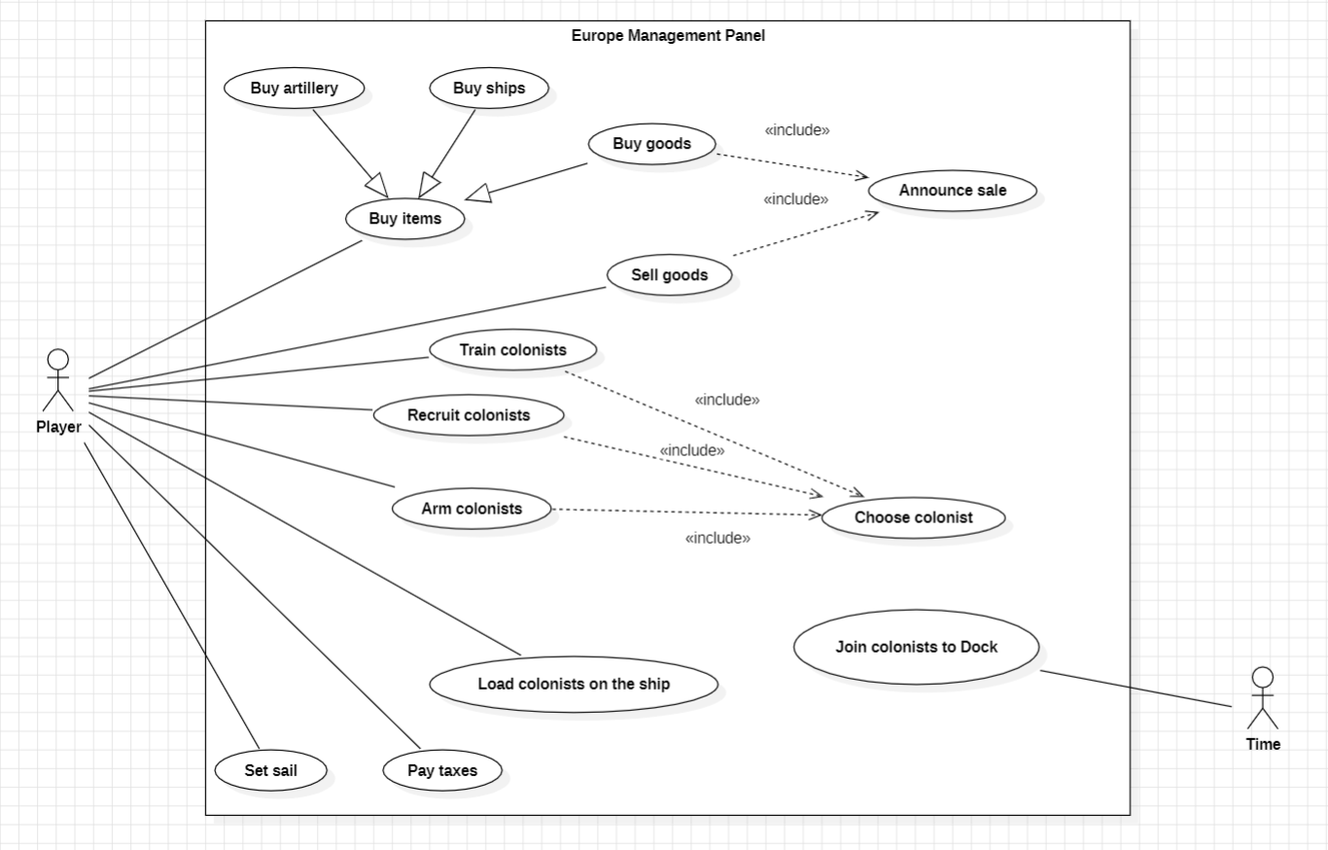

**Actors**

For this Use Case diagram, I identified two different types of actors that interact with the system:

Player: represents a human or an AI that plays the game.

Time: represents a random period of time that makes new colonists appear on the European panel.

**Use Cases**

Use case: **Buy items**

ID: 1

Description: The player tries to buy items such as artillery, new ships, or goods from the market. To buy them, the player must have enough gold.

Main actor: Player

Secondary actors: None

Use case: **Buy artillery**

ID: 2

Description: The player tries to buy artillery to use on his lands.

Main actor: Player

Secondary actors: None

Use case: **Buy goods**

ID: 3

Description: The player tries to buy goods (such as food, cotton, lumber,etc) from the market and load then on his ship.

Main actor: Player

Secondary actors: None

Use case: **Buy ships**

ID: 4

Description: The player tries to buy ships (such as caravels, galleons, frigates ,etc).

Main actor: Player

Secondary actors: None

Use case: **Announce sale**

ID: 5

Description: When the player buys or sells goods, appears on the screen a message with information about the sale (the name of the goods being purchased/sold, quantity, price).

Main actor: Player

Secondary actors: None

Use case: **Sell goods**

ID: 6

Description: The player can sell the goods that are on his boat to the market and make money from it.

Main actor: Player

Secondary actors: None

Use case: **Train colonists**

ID: 7

Description: The player can train a colonist to become an expert unit to then embark on his ship. To do it, the player must choose a colonist and pay for it.

Main actor: Player

Secondary actors: None

Use case: **Recruit colonists**

ID: 8

Description: The player can recruit a colonist from the New World to then embark on his ship. To do it, the player must choose a colonist and pay for it.

Main actor: Player

Secondary actors: None

Use case: **Arm colonists**

ID: 9

Description: The player can arm a colonist with tools. To do it, the player must pay for tools and then choose a colonist from the dock to arm with it.

Main actor: Player

Secondary actors: None

Use case: **Load colonists on the ship**

ID: 10

Description: The player can move colonists from the dock to the ships that are in European port.

Main actor: Player

Secondary actors: None

Use case: **Pay taxes**

ID: 11

Description: The player can pay taxes from boycotted goods allowing him to then sell his previous boycotted goods on the market.

Main actor: Player

Secondary actors: None

Use case: **Set sail**

ID: 12

Description: The player can remove his ship from the European port to the ocean for sailing.

Main actor: Player

Secondary actors: None

Use case: **Join colonists to Dock**

ID: 13

Description: The time makes colonists appear on the Dock panel. The player can then decide if he wants to load them on his ship.

Main actor: Time

Secondary actors: None

### The Colony Panel

This is the use case diagram of the colonies panel and it shows the interactions the player can have with it. This panel appears when the player selects a terrain tile on the map that belongs to them, and they can perform various actions, which are shown in the following diagram:

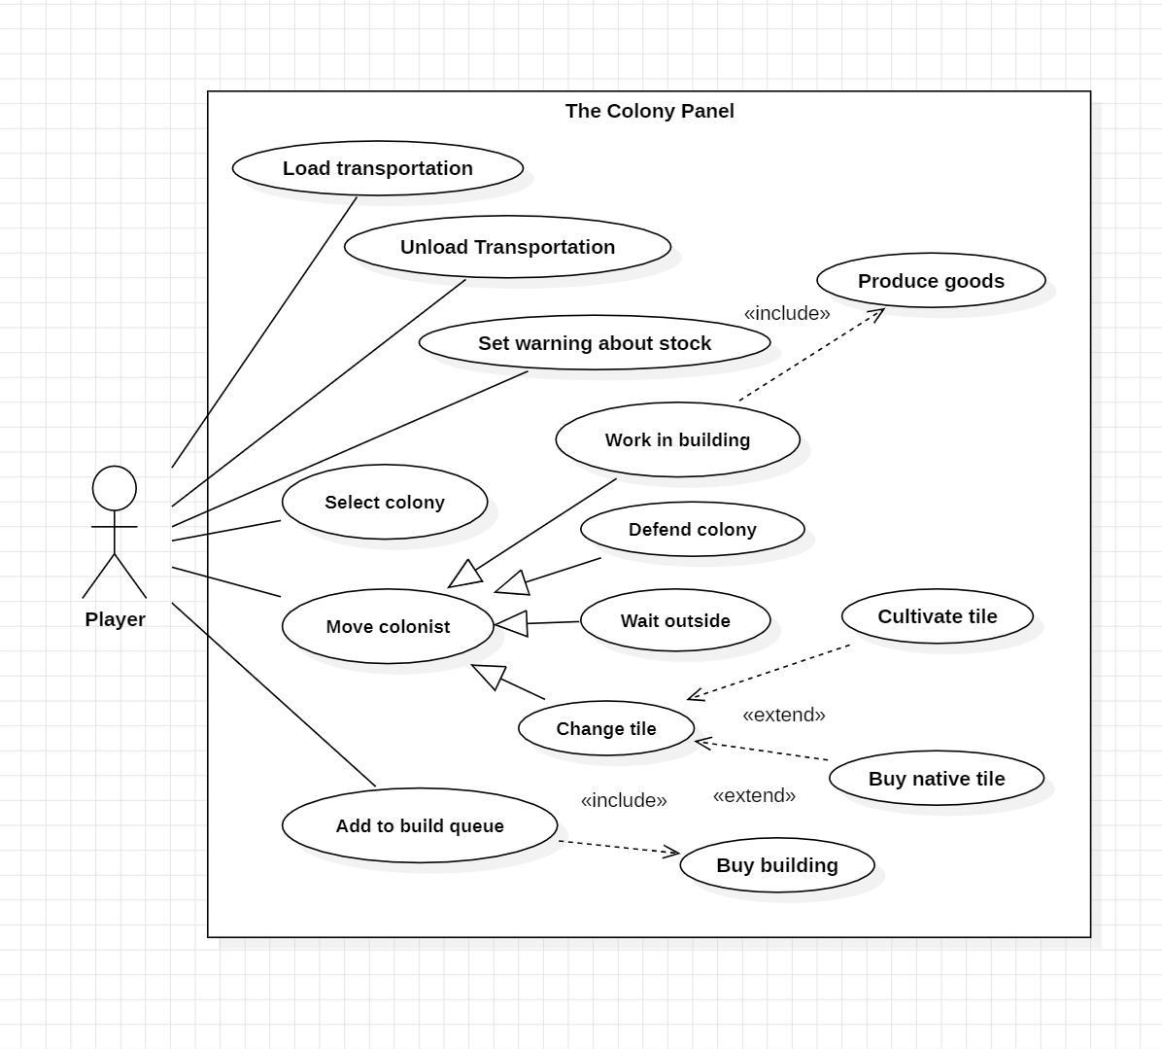

Now I’ll proceed to give a short explanation for each Use Case present on it:

Use Case: **Load Transportation**

ID:1

Description: The player can load the active ship or wagon train.

Main actor: Player

Secondary actor:None

Use Case: **Unload Transportation**

ID:2

Description: The player can unload the active ship or wagon train.

Main actor: Player

Secondary actor:None

Use Case: **Set warning about stock**

ID:3

Description: The player can set the warning levels for all types of goods, if the number of goods drops below the lower level or rises above the higher level.

Main actor: Player

Secondary actor:None

Use Case: **Select colony**

ID:4

Description: The player can select a different colony.

Main actor: Player

Secondary actor:None

Use Case: **Move colonist**

ID:5

Description: The player can drag the colonist through the panel: make him work in a building, defend the colony against attacks, move him from a tile to another one in the small map at the top left corner of the panel, or even move him outside, in other words, move him to the main map of the game.

Main actor: Player

Secondary actor:None

Use Case: **Add to build queue**

ID:6

Description: The player can add a building to the building queue

Main actor: Player

Secondary actor:None

**By**: Joana Monteiro (62689) -> joanamonteiro1809 (team_member3)

### Combat

This use case focuses on combat, which can be either Naval Combat or Unit Combat.

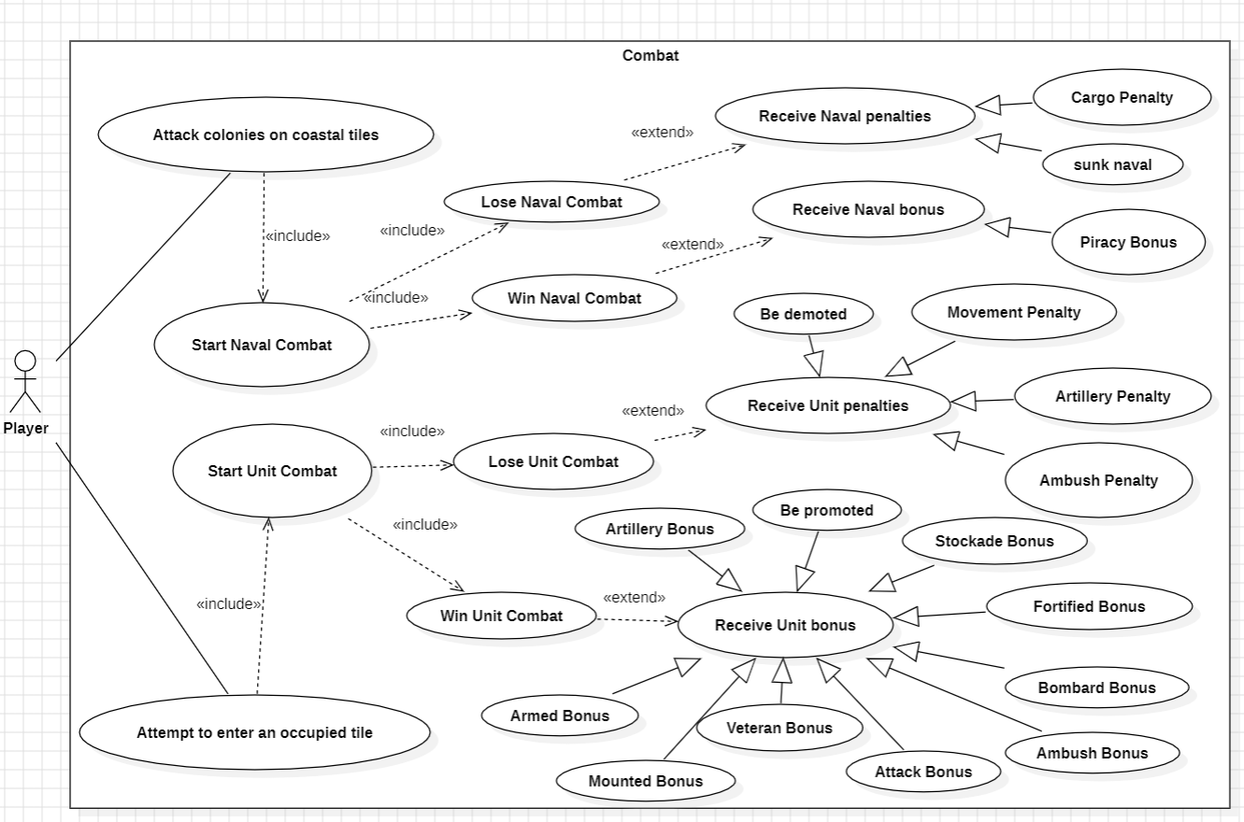

**Actor**

For this Use Case diagram, I identified one Actor:

Player: Can be either human or AI, and plays the game.

**Use Cases**

Use case: **Attempt to enter an occupied tile**

ID: 1

Description: If the player attempts to enter an occupied tile, they will start a unit combat. The winner receives Unit benefits such as Armed bonus, attack bonus, or bombard bonus, while the loser receives Unit penalties such as Ambush penalty, Artillery penalty, or movement penalty.

Main actor: Player

Secondary actors: None

Use case: **Attack colonies on coastal tiles**

ID: 2

Description: If the player attack colonies on coastal tiles, they will start a unit combat. The winner receives Naval benefits such as Piracy Bonus, while the loser receives Naval penalties such as Cargo Penalty or Sunk Naval.

Main actor: Player

Secondary actors: None

Use case: **Start Naval Combat**

ID: 3

Description: A naval combat begins, and the player can either win or lose.

Main actor: Player

Secondary actors: None

Use case**: Start Unit Combat**

ID: 4

Description: A Unit combat begins, and the player can either win or lose.

Main actor: Player

Secondary actors: None

Use case: **Lose Naval Combat**

ID: 5

Description: The player loses the naval combat and will receive some penalties.

Main actor: Player

Secondary actors: None

Use case: **Win Naval Combat**

ID: 6

Description: The player wins the naval combat and will receive some bonuses.

Main actor: Player

Secondary actors: None

Use case: **Lose Unit Combat**

ID: 7

Description: The player loses the unit combat and will receive some penalties.

Main actor: Player

Secondary actors: None

Use case**: Win Unit Combat**

ID: 8

Description: The player wins the unit combat and will receive some bonuses.

Main actor: Player

Secondary actors: None

Use case: **Receive Naval Penalties**

ID: 9

Description: The player who lost the naval combat will receive some penalties, such as Cargo Penalty or Sunk Naval.

Main actor: Player

Secondary actors: None

Use case: **Receive Naval Bonuses**

ID: 10

Description: The player who won the naval combat will receive some bonuses, such as Piracy Bonus.

Main actor: Player

Secondary actors: None

Use case: **Receive Unit Penalties**

ID: 11

Description: The player who lost the unit combat will receive some penalties, such as Ambush penalty, Artillery penalty, or movement penalty.

Main actor: Player

Secondary actors: None

Use case: **Receive Unit Bonuses**

ID: 12

Description: The player who won the naval combat will receive some bonuses, such as Armed bonus, attack bonus, or bombard bonus.

Main actor: Player

Secondary actors: None

**By**: Renata Henriques (63001) -> Renata-Tournour (team_member6)

### Initial Menus

Use case diagram for the initial menus that appear when entering the game to the Main Page.

Diagram:

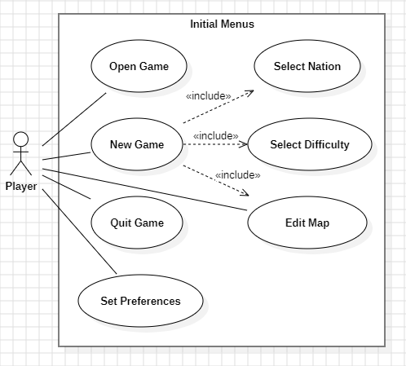

**Actors**

For this Use Case diagram, we identified one type of actor that interact with the system:

Player: represents a human that plays the game.

**Use Cases**

Name: **New Game**

Description: The player can start a game from the beginning.

Primary Actor: Player

Secondary Actor: None

Name: **Open Game**

Description: The player can pick up a game from where they left off in a previous session.

Primary Actor: Player

Secondary Actor: None

Name: **Quit Game**

Description: The player can leave the game.

Primary Actor: Player

Secondary Actor: None

Name: **Set Preferences**

Description: The player can choose details such as username, language as well as display and audio definitions.

Primary Actor: Player

Secondary Actor: None

Name: **Select Nation**

Description: The player can choose the nation they’re going to play as.

Primary Actor: Player

Secondary Actor: None

Name: **Select Difficulty**

Description: The player can choose the level of difficulty to play in.

Primary Actor: Player

Secondary Actor: None

Name: **Edit Map**

Description: The player can change the characteristics of the game map before or when starting a game.

Primary Actor: Player

Secondary Actor: None

**By**: Madalena Plácido (63001) -> mplacido3 (team_member4)

## Extensions

### Wagon Train Management

Use case diagram for the new type of Wagon Train.

**Diagram:**

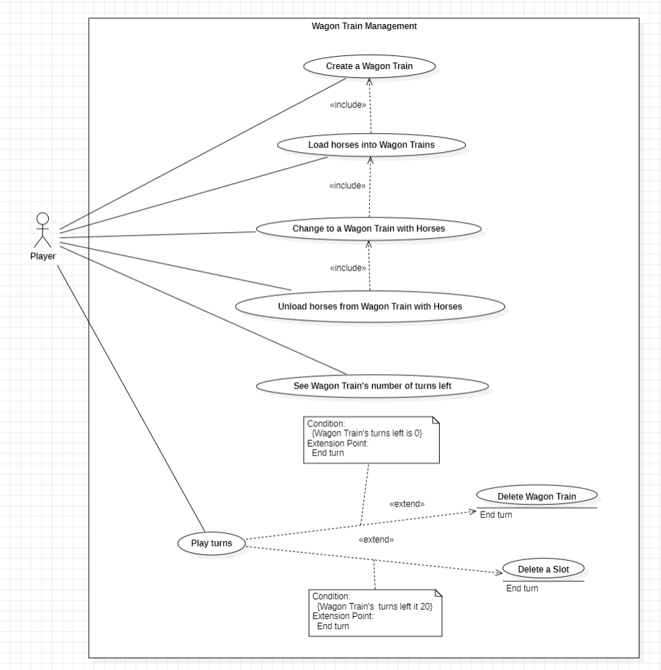

**Actors**

For this Use Case diagram, we identified one type of actors that interact with the system:

Player: represents a human or an AI that plays the game.

**Use Cases**

Use case: **Create a Wagon Train**

ID: 1

Description: The player produces a wagon train in the colony.

Main actor: Player

Secondary actors: None

Use case: **Load horses into Wagon Trains**

ID: 2

Description: The player tries to load horses into a wagon train previously created by him.

Main actor: Player

Secondary actors: None

Use case: **Change to a Wagon Train with Horses**

ID: 3

Description: The player tries to change his Wagon Train to a Wagon Train with horses, which moves faster (has more moves per turn).

Main actor: Player

Secondary actors: None

Use case: **Unload horses from Wagon Train with Horses**

ID: 4

Description: The player tries to unload horses from his Wagon Train with Horses, changing it back to Wagon Train.

Main actor: Player

Secondary actors: None

Use case: **See Wagon Train’s number of turns left**

ID: 5

Description: When the player selects a Wagon Train, he can see how many turns it has left before it breaks and disappears from the map and player’s cargo units.

Main actor: Player

Secondary actors: None

Use case: **Play turns**

ID: 6

Description: The player plays his turn in the game. When he’s finished, he clicks on “End Turn”.

Main actor: Player

Secondary actors: None

Use case: **Delete Wagon Train**

ID: 7

Description: When the player finishes his turn, if he has any Wagon Train with no turns left, it breaks and disappears from the map and player’s cargo units.

Main actor: Player

Secondary actors: None

Use case: **Delete a Slot**

ID: 8

Description: When the player finishes his turn, if he has any Wagon Train with 20 turns left, it loses a slot and all the goods that are in that slot.

Main actor: Player

Secondary actors: None

**By**:

Catarina Pedroso (61674) -> c-pedroso (team_member1)

Beatriz Rosas (63179) -> beatrizSPR9 (team_member5)

### Volcano

Use case diagram for the new type of tile Volcano.

**Diagram**:

|  |
| --- |
|  |

**Actors**

For this Use Case diagram, we identified one type of actors that interact with the system:

Player: represents a human or an AI that plays the game.

**Use Cases**

Name: **Find Volcano**

Description: The player finds a volcano while exploring the map

Primary Actor: Player

Secondary Actor: None

Name: **Earn ore**

Description: The player earns ore from the tile

Primary Actor: Player

Secondary Actor: None

Name: **Work on a volcano tile**

Description: The player places a worker on a tile

Primary Actor: Player

Secondary Actor: None

Name: **Earn silver**

Description: The player earns silver from the tile

Primary Actor: Player

Secondary Actor: None

Name: **Play turns**

Description: The player plays the game, in turns

Primary Actor: Player

Secondary Actor: None

Name: **Change volcanos to mountains**

Description: The tile changes from being a volcano to mountains

Primary Actor: Player

Secondary Actor: None

**By**:

Madalena Plácido (63001) -> mplacido3 (team_member4)

Renata Henriques (63215) -> Renata-Tournour (team_member6)

# Metrics

## Class Count Metric

This type of metrics has 6 different metrics: C, C(rec), Cp, Cp(rec), Ct and Ct(rec). Each one of these represents the number of classes the game has.

**Cp (Number of product classes)**

This metric counts the number of classes that has a specific functionality (for example, classes representing actions or players are considered product classes).

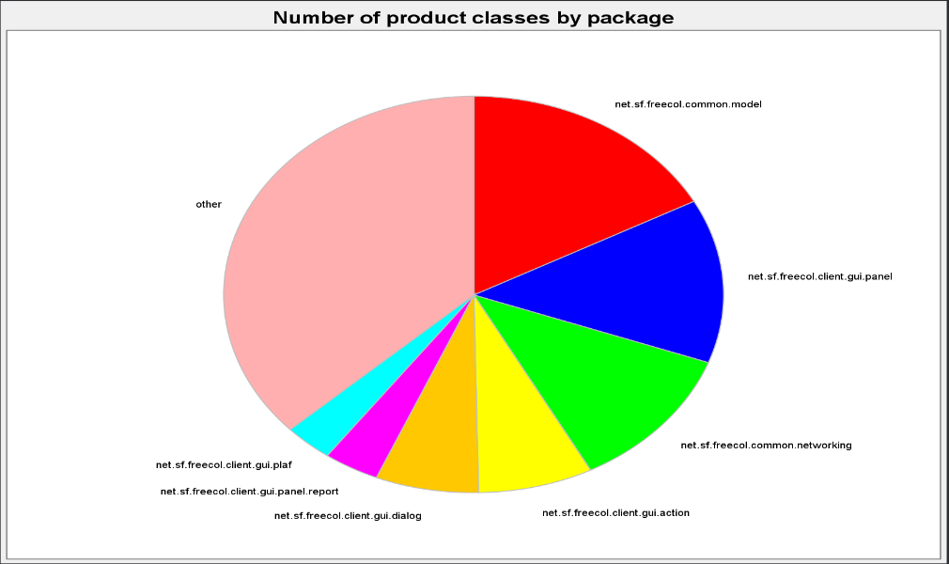



Looking at the pie chart for the number of product classes, we can conclude that the packages game.src.net.sf.freecol.common.model and game.src. net.sf.freecol.clinet.gui.panel have most of the product classes (with a total number of 196 and 153, respectively).

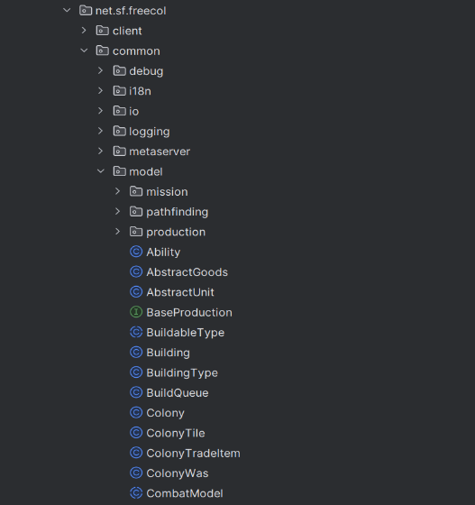

Looking at the game code, we can see that game.src.net.sf.freecol.common.model has several classes that are focused specifically on game functionalities.

**Cp(rec) (Number of product classes recursive)**

This metric counts the number of classes that are nested inside other classes. For example, if we have a class defined within another, this metric will count 2 (both the top-level class and the nested class). This metric is useful to understand the complexity and organization of the system. Analyzing the table of the metrics, we can observe that every main package has several recursive classes.













**Ct (Number of test classes)**

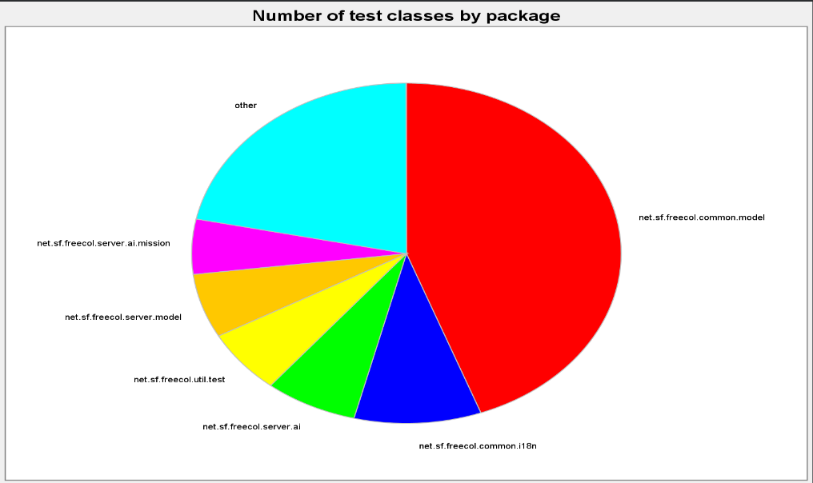This metric counts the number of classes used for testing the game itself.

Looking at the pie chart for the number of test classes, we can conclude that the package test.src.net.sf.freecol.common.model has most of the test classes (with a total number of 51).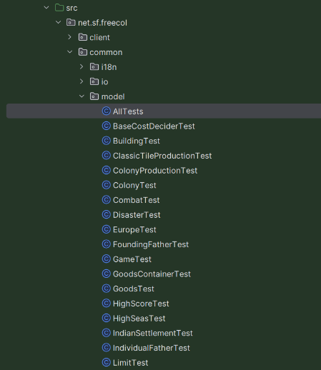Looking at the game code, we can see that test.src.net.sf.freecol.common.model has several classes that are focused on testing the game itself.

**Ct(rec) (Number of test classes recursive)**

Same as the Cp(rec), this metric counts the number of test classes that are defined within another test class. If this number is equal to the number of test classes, we can conclude that the package doesn’t have nested classes.

**C (Number of classes)**

This metric is equal to the sum of Cp and Ct metrics.

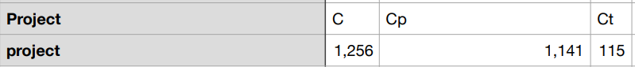



The Freecol project has a total number of 1256 classes. This is considered a reasonable number since the game is a complex system.

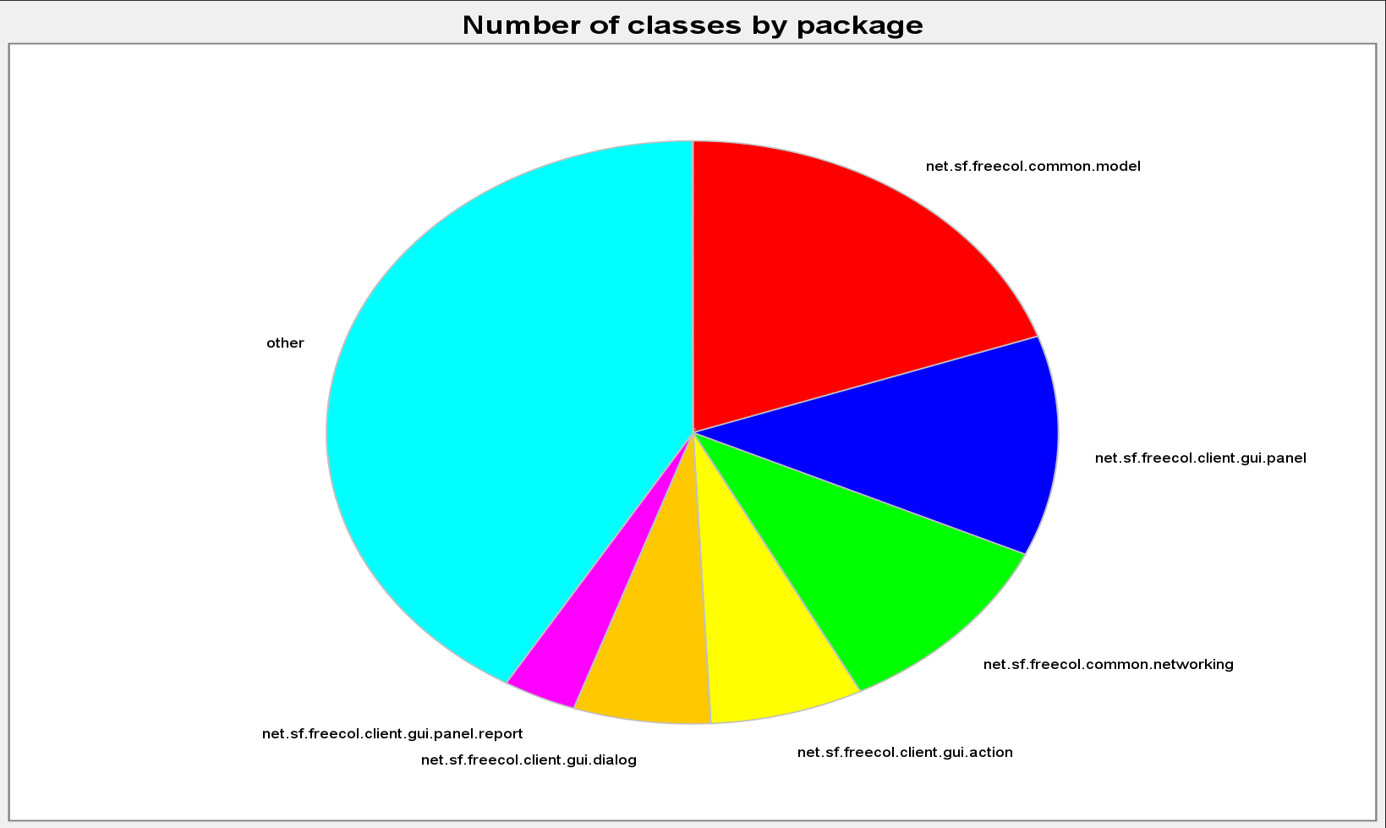

**C(rec) (Number of classes recursive)**

This represents de sum of Cp(rec) and Ct(rec), showing the total number of top-level classes and nested classes in each package.

## Dependency Metrics

## As for Dependency Metrics, there are a total of 7 metrics:

## - **Cyclic (number of cyclic dependencies):** corresponds to the number of cyclic dependencies of packages, i.e. it calculates the number of classes, interfaces that each class depends on directly or indirectly and which, in turn, depend on it directly or indirectly. This metric can also be used for package metrics.

## The maximum number of cyclic dependencies of both classes and interfaces is 804, meaning that there are countless cases in which, for example, a class A depends on another class B and, in turn, B depends on A.

## - **Dcy (number of dependencies):** Calculates the number of classes or interfaces on which each class depends directly. Compared to the "Cyclic" metric, the data is no longer as high, but class dependency is still high, with a maximum of 117 classes directly dependent on each other. There is an identical metric for packages: PDcy.

## - **Dcy* (number of transitive dependencies):** Calculates the number of classes or interfaces on which each class depends directly or indirectly. In other words, when component A depends on component B, and component B in turn depends on component C, then component A also has a transitive dependency on component C. According to the table, it is the metric with the highest value with 1084 dependent classes.

- **Dpt (number of dependents):** This metric is used to assess the degree of dependency that other classes or interfaces have on a specific class/interface. In other words, it measures how many other components or modules depend directly on the class itself. The maximum number of classes dependent on a class, for example, is 382. There is an identical metric for packages: PDpt.

- **Dpt* (number of transitive dependents):** The values of this metric represent the number of classes that depend directly or indirectly on the class itself, through transitive dependencies. This metric also has very high values: 937. There is also an identical metric for packages: PDpt*.

**- PDcy (number of package dependencies):** This metric evaluates the number of packages each class/interface is dependent on. The highest value in the table is 20.

- **PDpt (number of dependent packages):** Finally, this metric evaluates the number of packages that depend on the class itself. In this game, the maximum number of packages dependent on a class is 36.

Analyzing these values, it can be concluded that each metric in general has very high dependency values between classes, interfaces and packages. High values like these can indicate complexity and potential risks in the code: it hinders the testability of the code since classes with many dependencies are more difficult to test in isolation, it hinders the readability of the code since it is more difficult to trace how the different parts of the code interact and understand the impact of a change, and it increases the frequency of the code smell "inappropriate intimacy". These characteristics are to be avoided since our goal with the code is that, as well as being functional, it should also be readable, testable and easy to maintain over time.

## Complexity metrics:

The complexity metrics are a way of measuring how difficult a unit of code is to understand and read. The complexity of the project also impacts how costly it is to maintain.

**At the method level:**

ev(G): Essential cyclomatic complexity

CogC: Cognitive complexity

iv(G): Design complexity

v(G): Cyclomatic complexity

**At the Class level:**

OCavg: Average operation complexity

OCmax: Maximum operation complexity

WMC: Weighted method complexity

**At the package/module/project level:**

V(G)avg: Average cyclomatic complexity

V(G)tot: Total cyclomatic complexity

**Cyclomatic Complexity:**

Represents the quantitative measure of the number of linearly independent paths of a code section.

Programs with lower Cyclomatic complexity are easier to understand and less risky to modify, a higher value means the code will be harder to test and has a higher risk of defects.

Measured as:

M = E – N +2P

E = number of edges in the control flow graph

N = number of nodes in the control flow graph

P = number of connected components

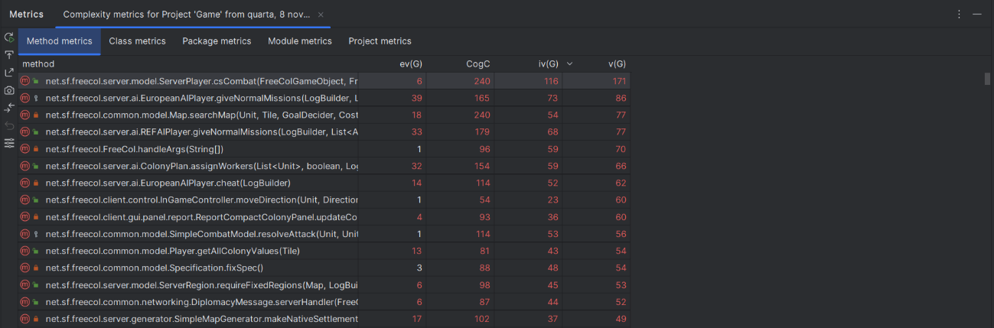

* **Cognitive complexity:**

Measures how difficult it is to read and understand the code, it takes into consideration the use of shorthands to collapse multiple statements into one, breaks in the flow such as loops, conditionals, switches…, and nested flow-breaking structures.

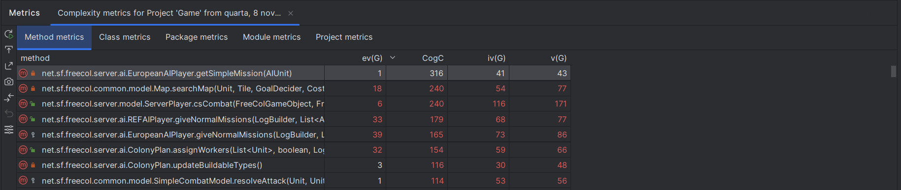

Example from the worst evaluated method:

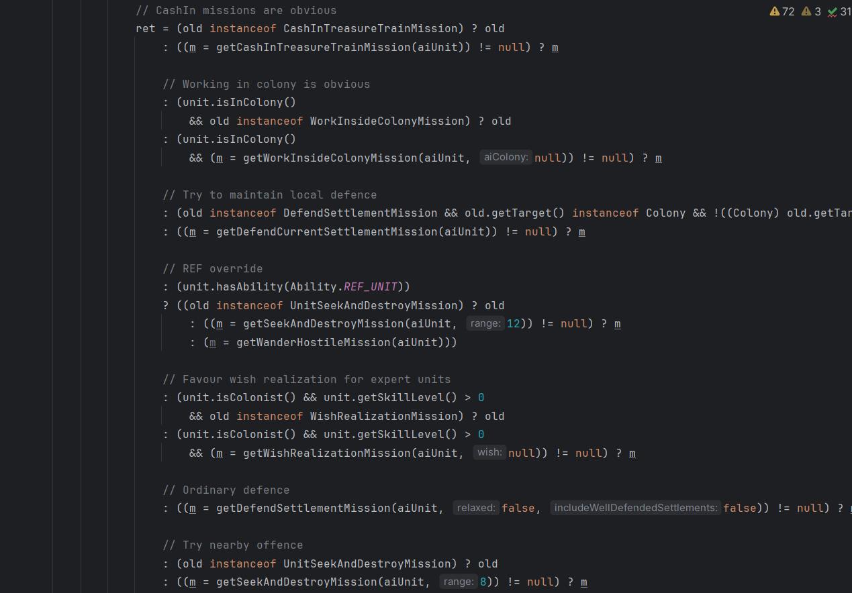

### Martin Packaging Metrics

The Martin Packaging Metrics were introduced by Robert “Uncle Bob” Martin in 1994. This metrics only focus on the relationship between packages in the project.

Martin’s metrics include:

* Efferent Coupling (Ce)
* Afferent Coupling (Ca)
* Instability (I)
* Abstractness (A)
* Normalized Distance from Main Sequence (D)

**Efferent Coupling (Ce):**

This metric is used to measure the total number of classes inside a package that depend on classes outside this package.

Packages with a **high** CE (>20) are considered problematic because they have a negative impact on package reusability and maintainability.

In the FreeCol code, most classes have a CE greater than 20, indicating that these classes have strong dependencies on classes from other packages.

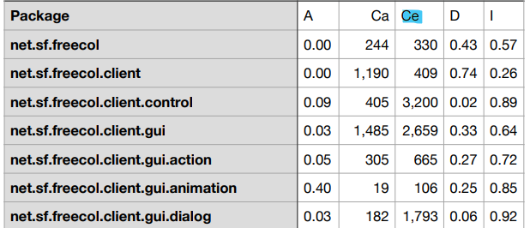

**Afferent Coupling (Ca):**

This metric measure the total number of classes outside a package depend on classes within that package, directly related to portability.

Packages with a **high** CA (>500) are bad packages because it means that class depends on many other classes and they are harder to be replaced since they have a lot of other packages that depend on them.

In the FreeCol code, there are some classes with a good CA (Afferent Coupling) and others with a poor CA:

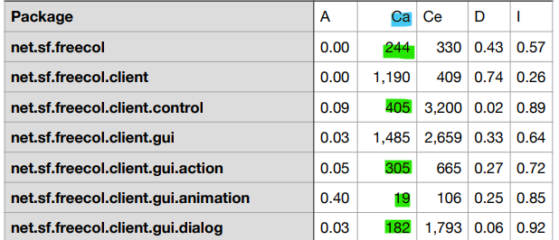

**Instability (I):**

This metric measures the instability of packages, by calculating the effort to change a package without impacting other packages within the application. Measures the ratio between **CE and CE+CA**. Values between 0 and 1 are acceptable.

In the FreeCol code, all classes have an I value between 0 and 1.

If the value is near 0, it means that the ones having many incoming dependencies and not many of outgoing

If the value is near 1, it means that the ones having many outgoing dependencies and not many of incoming ones

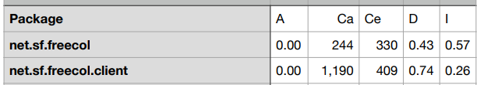

**Abstractness (A):**

This metric measures how abstract a package is, calculating the ratio between the number of abstract classes or interfaces and the total number of classes inside a package (**A = Na / Nc**).

If the value is near 0, means that all classes in this package are non-abstract while the value near 1 shows a package that only consists of abstract classes and interfaces.

Exemple of a abstract package and one non-abastract:

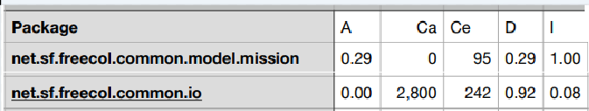

**Normalized Distance from Main Sequence (D):**

This metric measures the balance between stability and abstractness and is calculated using the following formula **D = | (A + I) – 1|.**

Two extremely unfavourable cases are considered:

* A = 0 and I = 0: package is extremely stable and concrete.
* A = 1 and I = 1: rather impossible situation because a completely abstract package must have some connection to the outside.

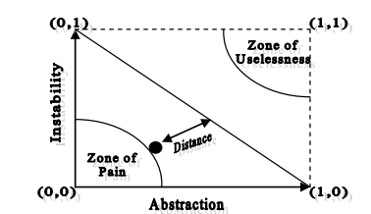

**By**: Renata Henriques (63001) -> Renata-Tournour (team_member6)

## Lines Of Code Metric

The metric “Lines of Code” counts the number of lines in a program’s source code. It’s a simplistic measure used to assess the dimension and complexity of a project. When used exclusively, it may not accurately reflect reality and can be misleading, as its value is significantly influenced by external factors such as the language used. The number of lines is not directly related to the program’s quality. Therefore, it is best used with other metrics for a more accurate analysis.

For our project, the levels worth considering are the class and method levels.

At the class level, the following fields can be analyzed:

• CLOC – Comment Lines Of Code;

• JLOC – Javadoc Lines Of Code;

• LOC – Lines Of Code.

In addition to the ones mentioned above, at the method level, the following fields exist:

• NCLOC – Non-Comment Lines Of Code

• RLOG – Relative Lines Of Code. It calculates the ratio between the lines of code in the method and the lines of code in its class.

**Potential Trouble Spots in the codebase and related code smells**

At the class level, the high values in the field LOC point towards the code smell large class. Examples follow:

|  |
| --- |
|  |

At the method level, the high values in field LOC point towards the code smell long method. Examples follow:

|  |
| --- |
|  |

**By**: Madalena Plácido (63001) -> mplacido3 (team_member4)

# Design Patterns

## Design Pattern 10

**Type**: Composite

**Location:**

Abstract Class: Game/src/net/sf/freecol/common/option/AbstractOption.java

Subclasses:

Game/src/net/sf/freecol/common/option/AudioMixerOption.java

Game/src/net/sf/freecol/common/option/BooleanOption.java

Game/src/net/sf/freecol/common/option/FileOption.java

Game/src/net/sf/freecol/common/option/OptionGroup.java

When analyzing the Option package, it is possible to find an abstract class *AbstractOption* that has several subclasses (such as *AudioMixerOption*, *BooleanOption*, *FileOption*, *OptionGroup*, etc.). The *OptionGroup* subclass has, unlike the others, a List-type data structure that allows storing a set of Option-type objects and a set of operations that allow adding or removing Options-type objects from that same list. When observing this behavior, I concluded that I was facing a Composite Pattern. Thus, the *AbstractOption* class represents the Component class, the *OptionGroup* class represents the Composite class as it can be made up of several Leaves or several Composites and the remaining classes represent Leaf classes.

**Code snippet:**









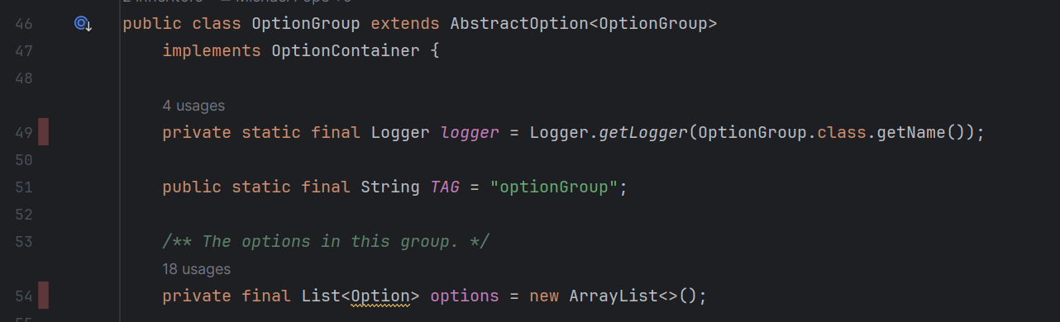

Methods from OptionGroup class:

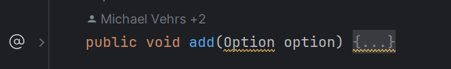

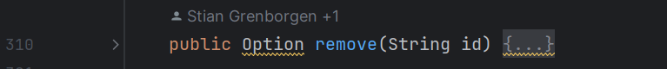

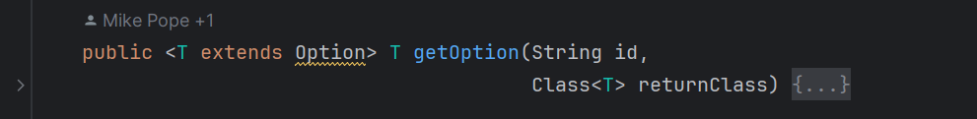

**Class diagram:**

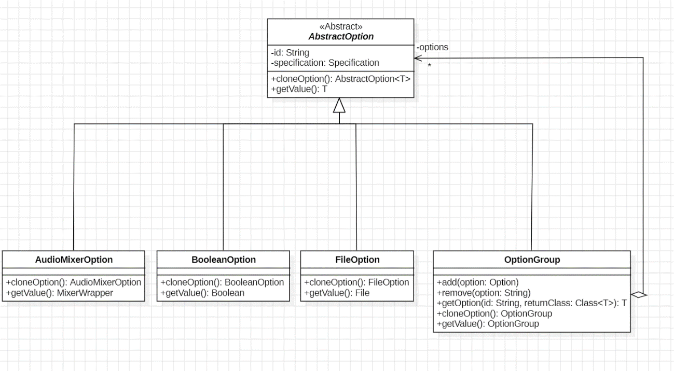

**By**: Beatriz Rosas (63179) -> beatrizSPR9 (team_member5)

## Design Pattern 11

**Type**: Decorator

**Location**:

Abstract Classes:

Game/src/net/sf/freecol/common/model/FreeColGameObject.java

Game/src/net/sf/freecol/common/model/TileItem.java

Subclasses:

Game/src/net/sf/freecol/common/model/Tile.java

Game/src/net/sf/freecol/common/model/TileImprovement.java

Game/src/net/sf/freecol/common/model/Resources.java

When analyzing the Model package, I noticed that it stores several types of objects that are used in the game. However, I focused only on those related to tiles, allowing the diagram presented above to be drawn. This demonstrates that, in addition to the *Tile* object, there is also an abstract *TileItem* class that represents features that can be added to tiles, such as improvements (roads or rivers) or resources (sugar, silver, etc.). I consider this to be a Decorator Pattern since, instead of creating several subclasses that represent the various combinations of Tiles and characteristics that exist, we create an abstract *TileItem* subclass that works as a Decorator. Thus, in the future, it becomes possible to create new characteristics that can be added to objects of the *Tile* type, simply by specifying the *TileItem* class with this new subclass.

**Code snippet:**





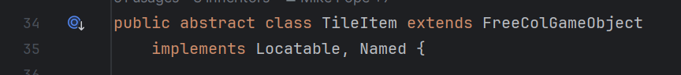



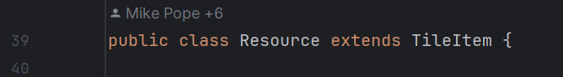

**Class diagram:**

For simplicity, I didn’t include the UnitLocation class on the diagram since Tile class extends UnitLocation class that extends FreeColGameObject class.

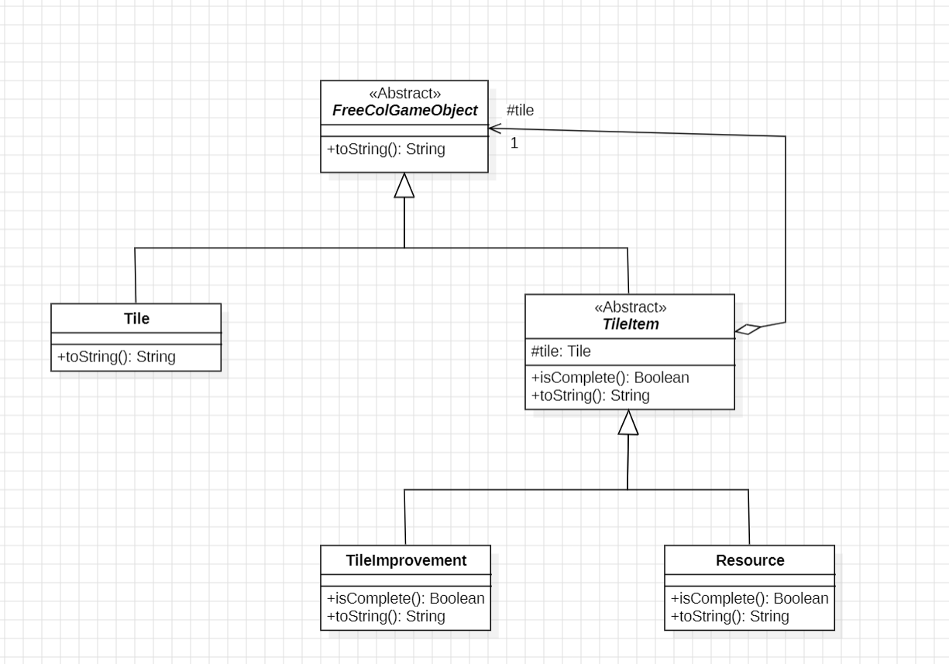

**By**: Beatriz Rosas (63179) -> beatrizSPR9 (team_member5)

## Design Pattern 12

**Type**: Template Method

**Location**:

Abstract Class: Game/src/net/sf/freecol/client/control/MapTransform.java

Subclasses: Game/src/net/sf/freecol/client/gui/panel/MapEditorTransformPanel.java

When analyzing the Control package, I noticed that there is an abstract *MapTransform* class responsible for the transformations that can be made in Map Editor mode. This class is also extended by six (private) subclasses that are defined in the *MapEditorTransformPanel* class: *SettlementTransform*, *TileTypeTransform*, *LostCityRumourTransform*, *ResourceTransform*, *RiverStyleTransform* and *RiverTransform*. In the *MapTransform* class there is an abstract method **transform (Tile t)** that is overridden in each subclass. Therefore, I consider that we are facing a Template Method Pattern, where the *MapTransform* class is the template class for its subclasses.

**Code snippet**:

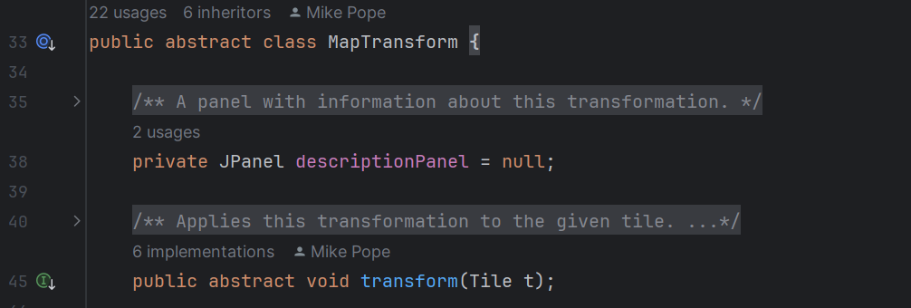

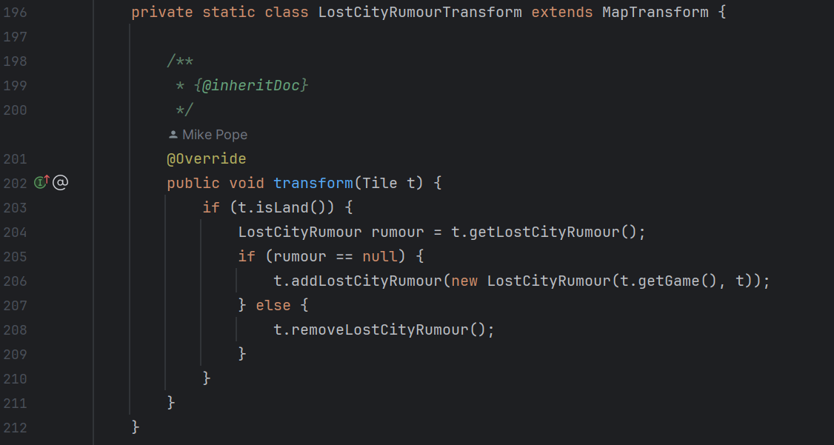

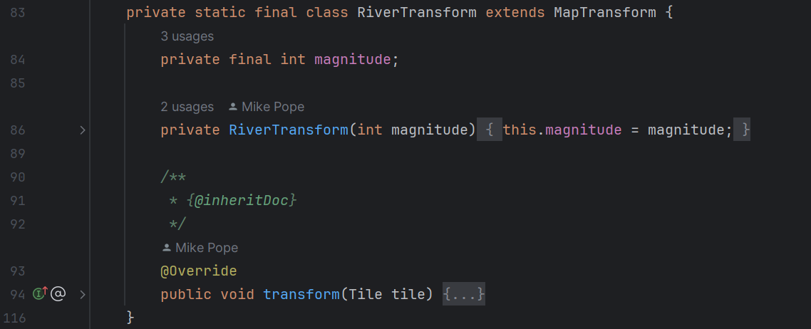

**Class diagram**:

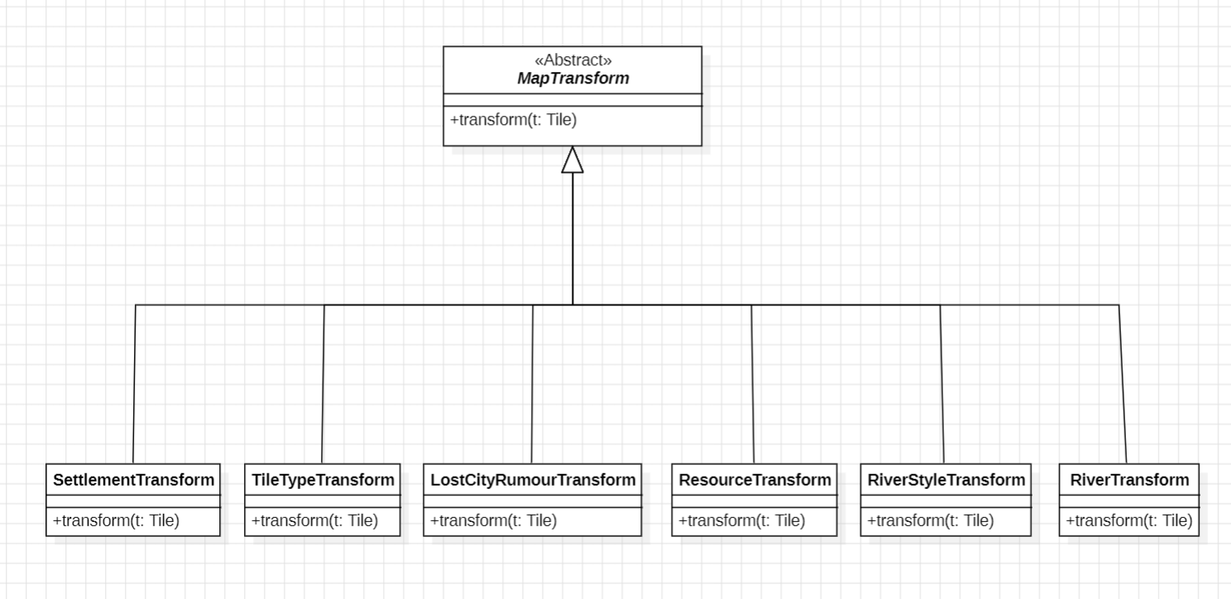

**By**: Beatriz Rosas (63179) -> beatrizSPR9 (team_member5)

Design Pattern 13

* **Template Pattern**

Diagram:

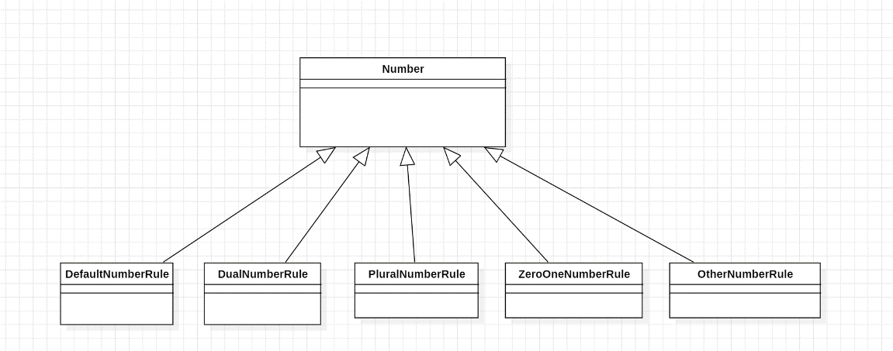

Localization:

Abstract class: Template>src>net>sf>freecol>common>i18n>Number

SubClasses:

-Template>src>net>sf>freecol>common>i18n>ZeroOneNumberRule

-Template>src>net>sf>freecol>common>i18n>DefaultNumberRule

-Template>src>net>sf>freecol>common>i18n>DualNumberRule

-Template>src>net>sf>freecol>common>i18n>PluralNumberRule

-Template>src>net>sf>freecol>common>i18n>OtherNumberRule

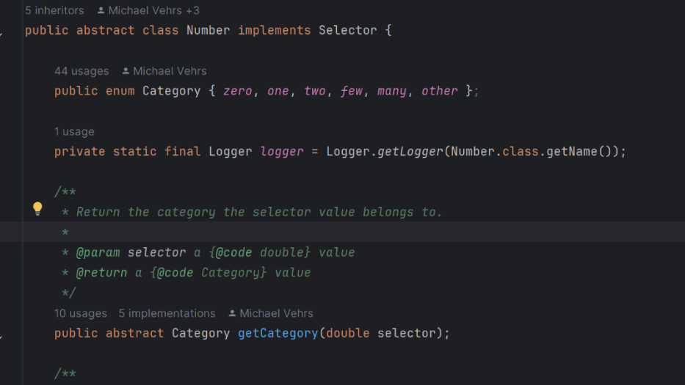Code:

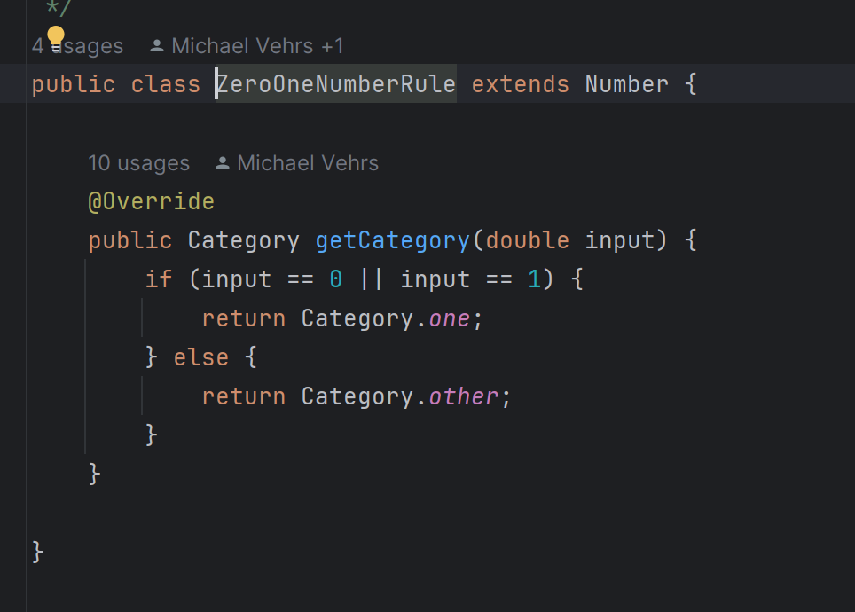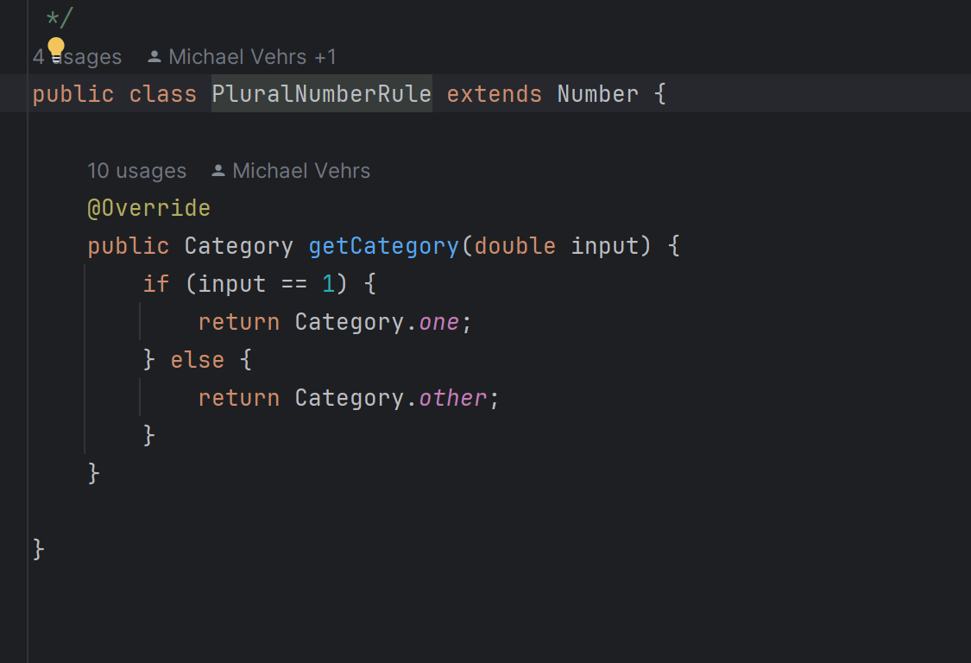

This design pattern helps create a framework for algorithms, where the overall structure is defined in an abstract class “Number”, and specific details are implemented in the 5 subclasses: “ZeroOneNumberRule”, “PluralNumberRule”,” DualNumberRule”, “DefaultNumberRule” and “OtherNumberRule”.

**By**: Joana Monteiro (62689) -> joanamonteiro1809 (team_member3)

Design Pattern 14

* 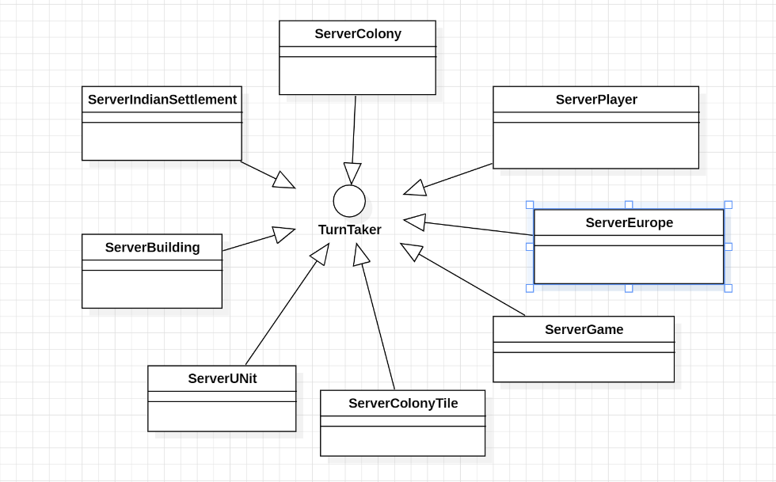**Factory Method:**

Diagram:

Localization of the interface: src> net> sf> freecol>server>model> TurnTaker

Code:

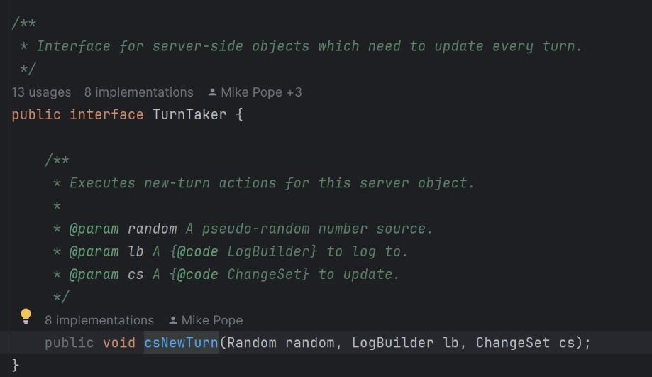

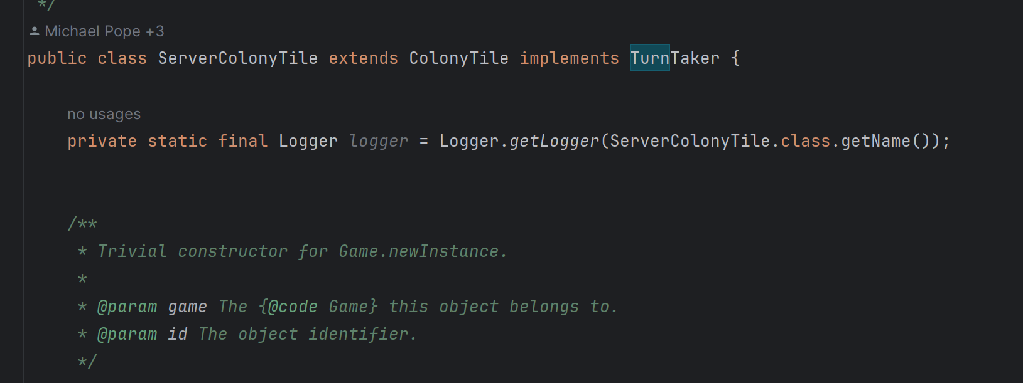

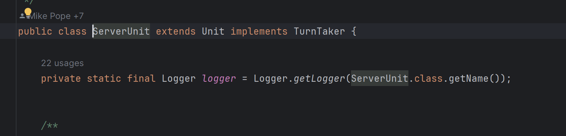

This design pattern provides an interface for creating objects but allows subclasses to alter the type of objects that will be created. It abstracts the process of object creation and promotes flexibility and decoupling between the creator and the concrete products.

**By**: Joana Monteiro (62689) -> joanamonteiro1809 (team_member3)

Design Pattern 15

* **Memento method:**

Diagram:

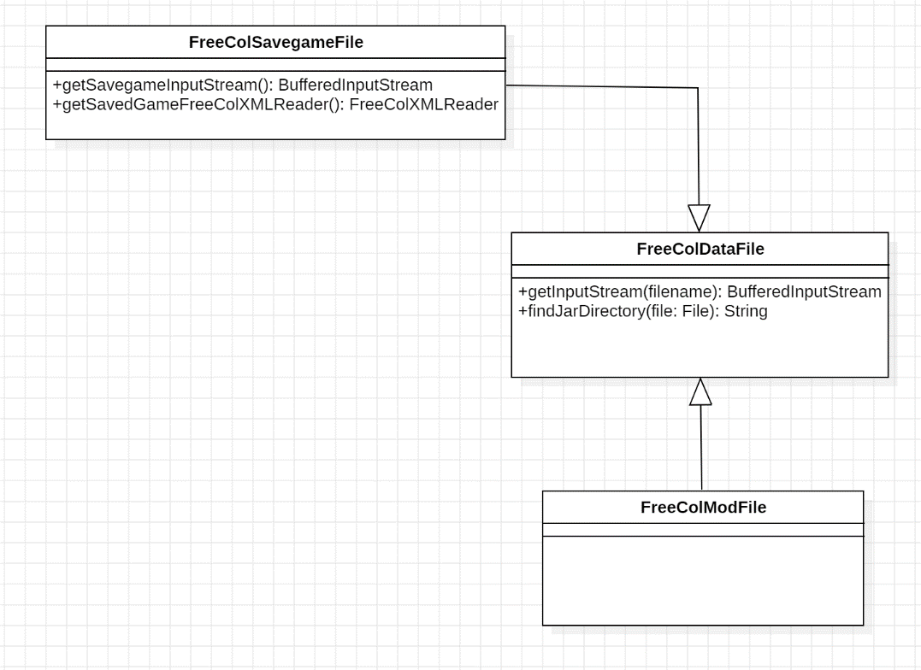

Localization of the class that represents the Memento: src> net> sf>freecol>common>io> FreeColDataFile, the Originator: src> net> sf>freecol>common >io > FreeColSavegameFile, and the CareTaker: src> net> sf>freecol>common >io > FreeColModFile.

Code:

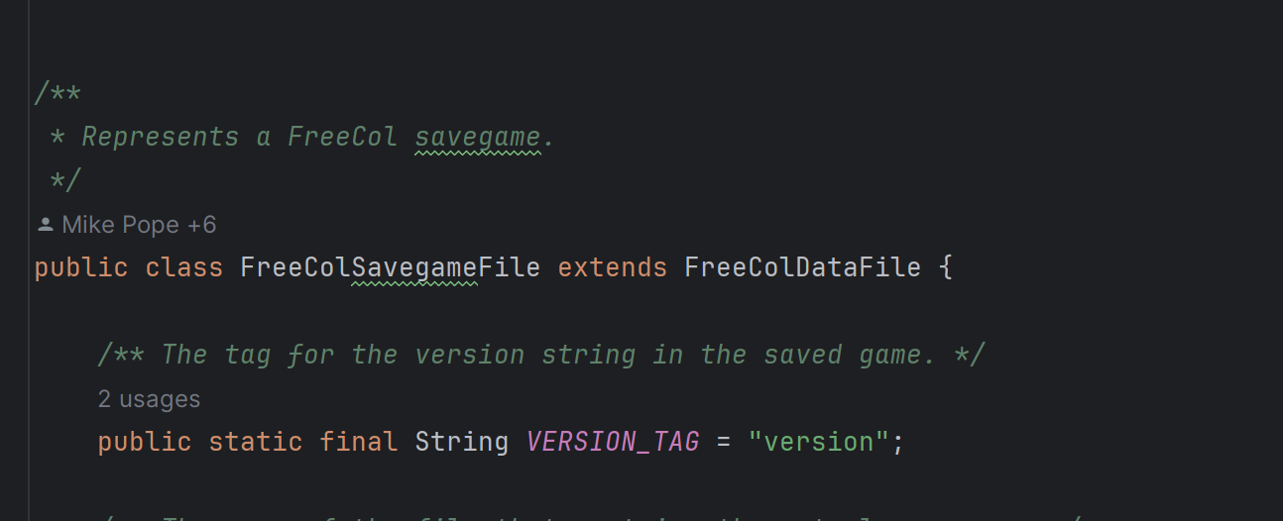

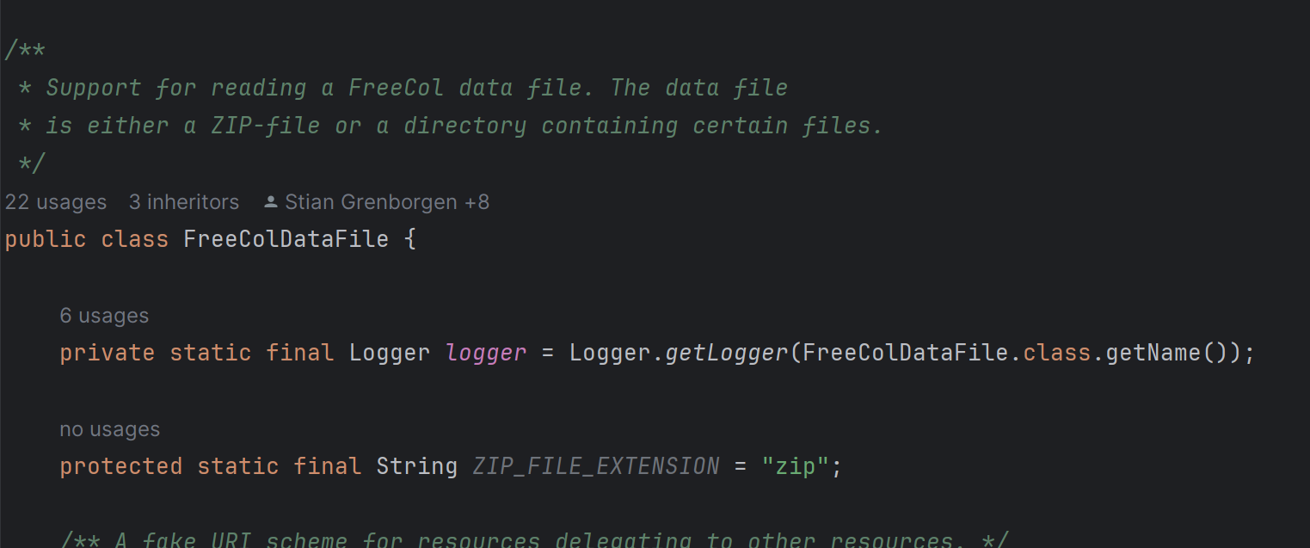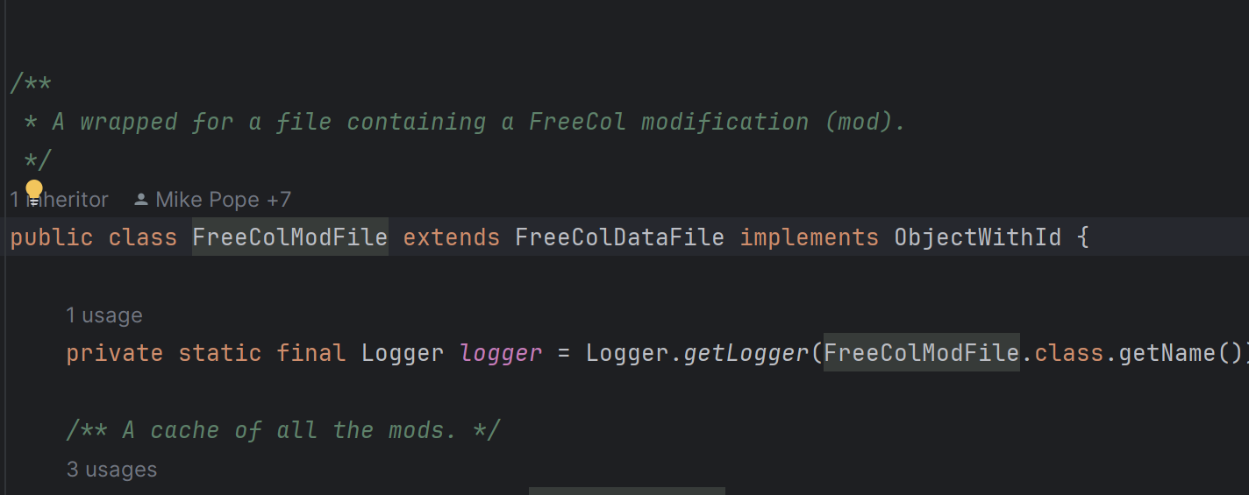

This design pattern provides a way to capture and externalize an object's internal state so that it can be restored to that state later. It’s composed of an Originator class, in this case, the FreeColGamesaveFile, a Memento class, which is the FreeColDataFile, and last but not least, the CareTaker class, which is the FreeColModFile.

**By**: Joana Monteiro (62689) -> joanamonteiro1809 (team_member3)

Design Pattern 16- Observer:

**Locations:**

Game/scr/net.sf.freecol/common/model/FreeColGameObjectListener.java

Game/scr/net.sf.freecol/common/model/FreeColGameObject.java

Game/src/ net.sf.freecol/server/ai/AIMain.java

Game/scr/net.sf.freecol/common/model/Game.java

The class AIMain keeps references of the class FreeColGameObject, using the interface FreeColGameObjectListener, it knows when an instance of that class is created, deleted, or changed owner.

The Game class keeps an instance of the FreeColGameObjectListerner interface and notifies them if a change to the GameObject happens.

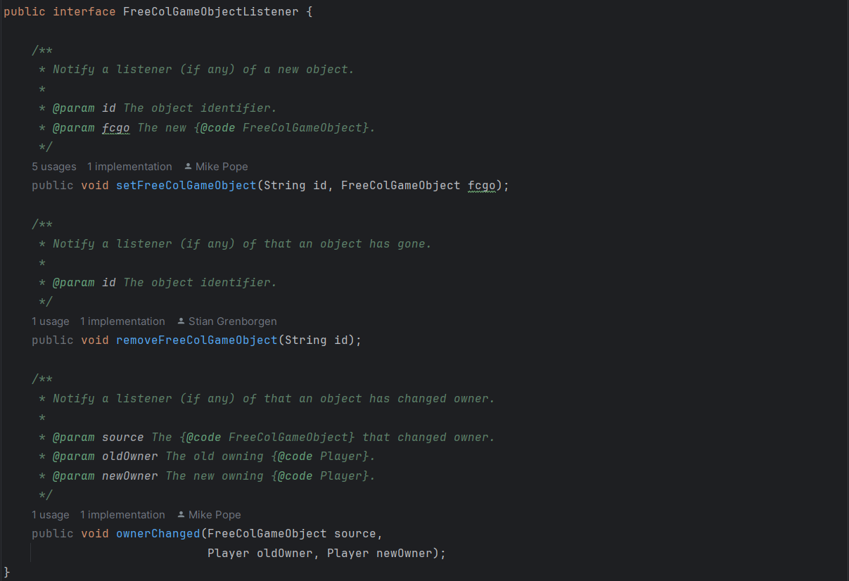

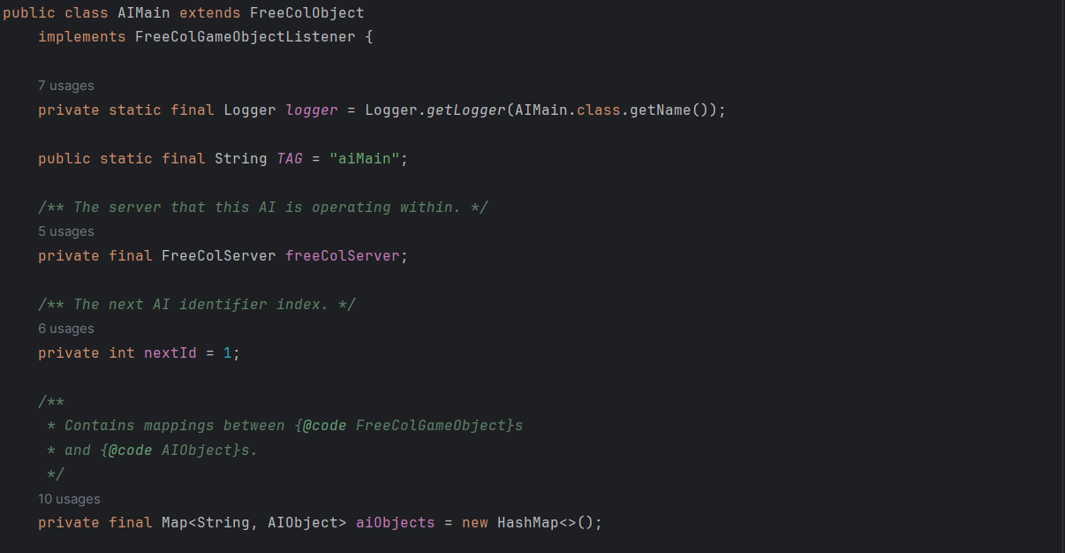

Game.js:

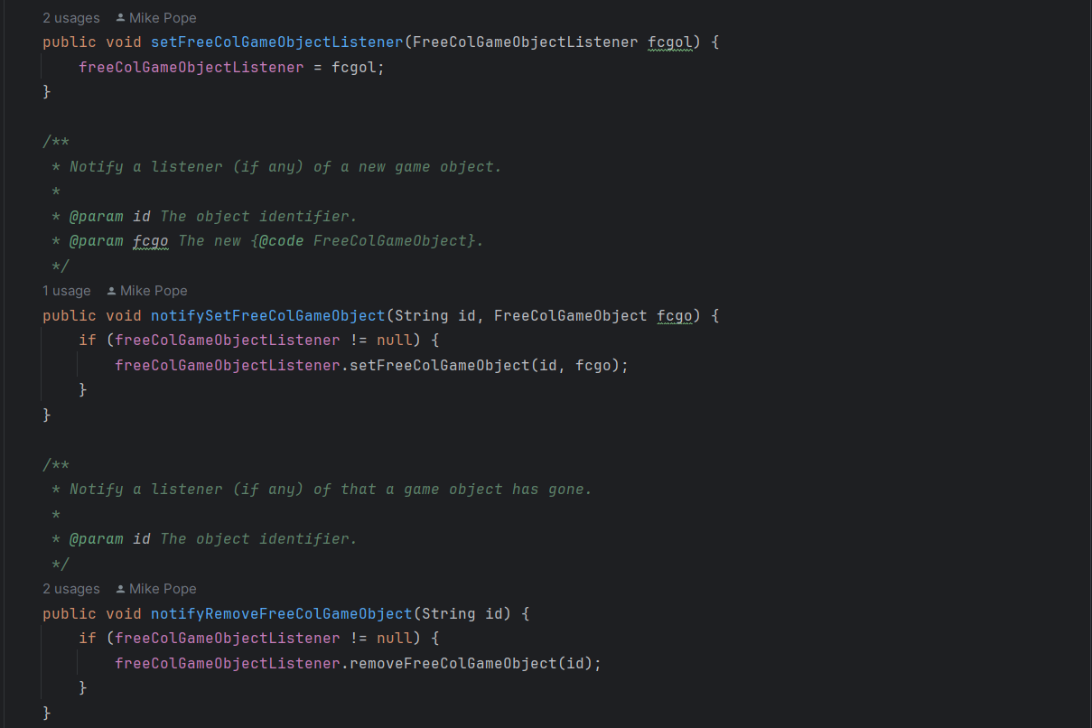

**Class Diagram:**

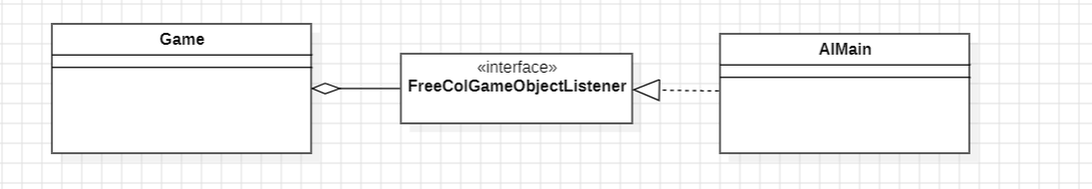

**By**: Catarina Costa (62497) -> cgcostaFCT (team_member2)

Design Pattern 17- Facade:

**Locations:**

Game/src/ net.sf.freecol/server/FreeColServer.java

The class FreeColServer is the one that allows the creation of several classes such as InGameContoller() and ServerInputHandler().

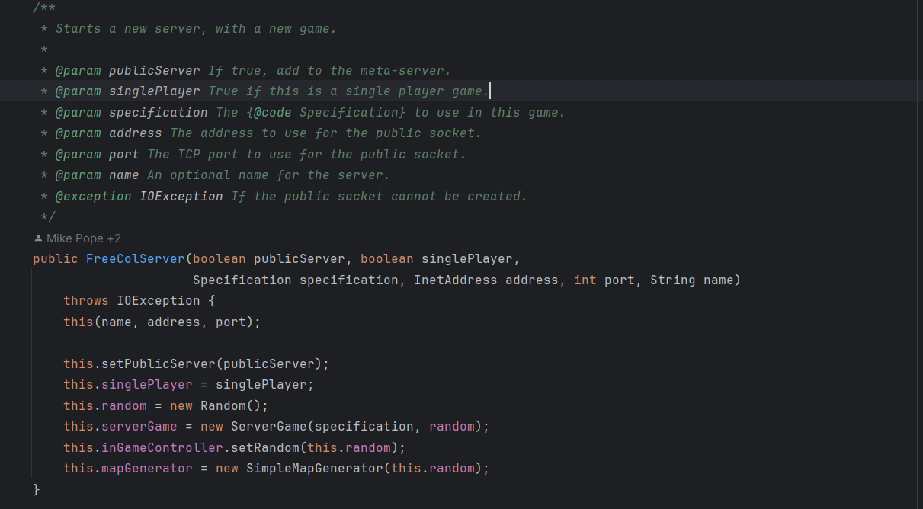

**Class Diagram:**

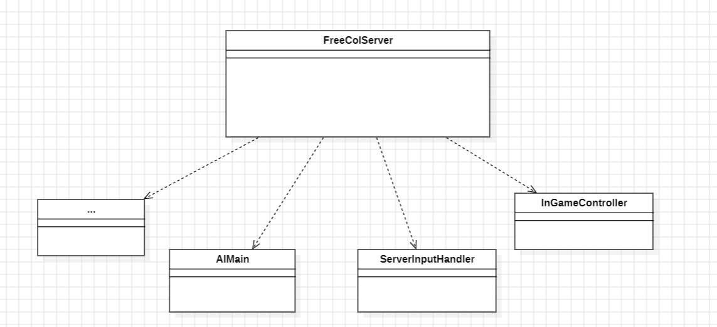

**By**: Catarina Costa (62497) -> cgcostaFCT (team_member2)

Design Pattern 18- Memento

**Location:**

Game/scr/net.sf.freecol/common/model/LastSale.java

Game/scr/net.sf.freecol/common/model/ChangeSet.java

Game/scr/net.sf.freecol/common/model/Player.java

The LastSale class is the memento class that stores the information of the last sale.

The originator in this exemple is the ChangeSet class, in there the lastSale object is created with the information passed to the addSale() method, the lastSale is then stored in the player class, making this one the caretacker of it.

LastSale:

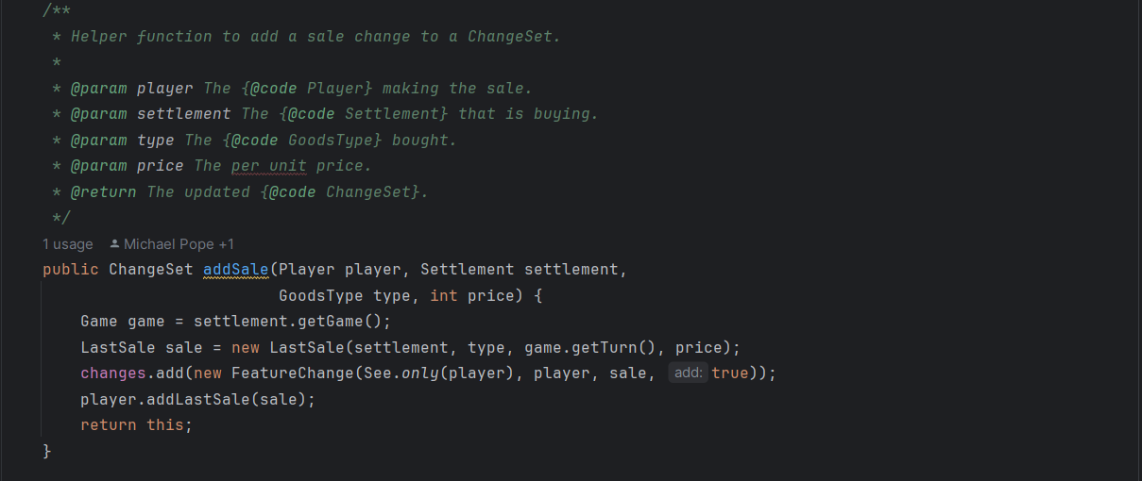

Player:

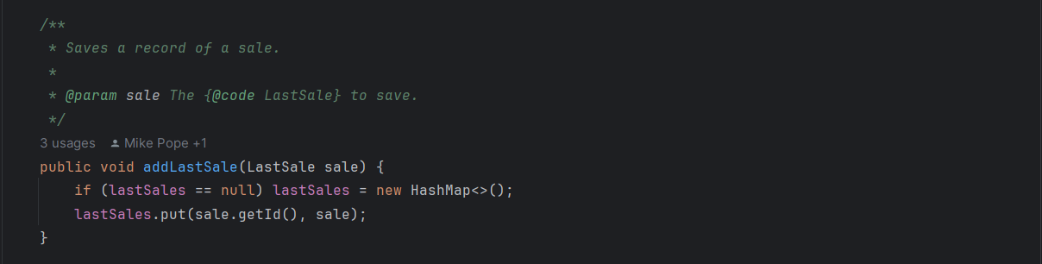

ChangeSet:

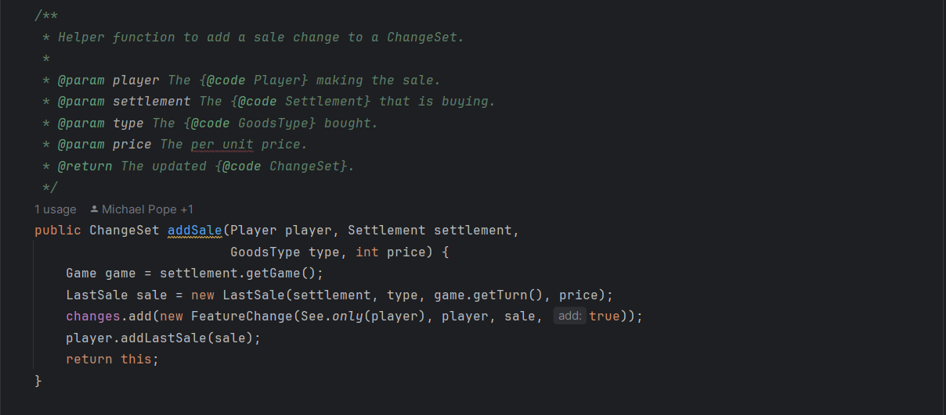

**Class Diagram:**

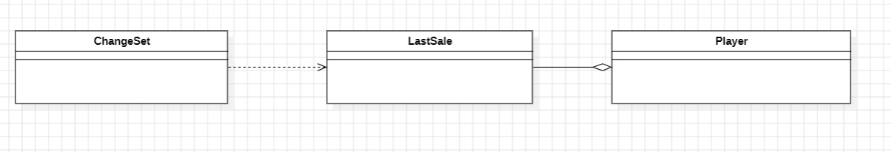

**By**: Catarina Costa (62497) -> cgcostaFCT (team_member2)

## Design Pattern 19

**Type**: Composite

**Location**:

Game.src.net.sf.freecol.common.model.mission.AbstractMission.java

Game.src.net.sf.freecol.common.model.mission.CompoundMission.java

Game.src.net.sf.freecol.common.model.mission.GoToMission.java

Game.src.net.sf.freecol.common.model.mission.ImprovementMission.java

Game.src.net.sf.freecol.common.model.mission.Mission.java

This structural design pattern allows objects to be composed in trees and work with the structures as individual objects. I found it because the CompoundMission class (the container) can have elements like the leaves (ImprovementMission and GoToMission classes) or other containers.

**Code snippet**:

|  |
| --- |
|  |

**Class Diagram**:

|  |
| --- |
|  |

## 

**By**: Madalena Plácido (63001) -> mplacido3 (team_member4)

## Design Pattern 20

**Type**: Template Method

**Location**:

Game.scr.net.sf.freecol.common.networking.TrivialMessage.java

Game.scr.net.sf.freecol.common.networking.AttributeMessage.java

Game.scr.net.sf.freecol.common.networking.ReconnectMessage.java

Game.scr.net.sf.freecol.common.networking.StartGameMessage.java

Game.scr.net.sf.freecol.common.networking.RequestLaunchMessage.java

Game.scr.net.sf.freecol.common.networking.ContinueMessage.java

Game.scr.net.sf.freecol.common.networking.RetireMessage.java

Game.scr.net.sf.freecol.common.networking.DisconnectMessage.java

Game.scr.net.sf.freecol.common.networking.EnterRevengeModeMessage.java

Game.scr.net.sf.freecol.common.networking.EndTurnMessage.java

This behavioral design pattern defines an outline of an algorithm in the superclass and lets the subclasses redefine the implementation of those methods. The methods shown in the code snippet of the subclasses are redefining the methods in the abstract class TrivialMessage.

**Code snippet**:

|  |  |
| --- | --- |
|  |  |

**Class Diagram**:

|  |
| --- |
|  |

# 

**By**: Madalena Plácido (63001) -> mplacido3 (team_member4)

## Design Pattern 21

**Type**: Memento

**Location**:

Game.src.net.sf.freecol.common.model.Unit

Game.src.net.sf.freecol.common.model.UnitWas

Game.src.net.sf.client.control.InGameController

This behavioral design pattern allows the process of saving and restoring the previous state of objects. The class InGameController needs the previous unit state which is stored in the class UnitWas.

**Code snippet**:

|  |
| --- |
|  |

**Class Diagram**:

|  |
| --- |
|  |

**By**: Madalena Plácido (63001) -> mplacido3 (team_member4)

## Design Pattern 22

**Type**: Template Method

**Location**:

**Abstract class:**

Game.src.net.sf.freecol.server.ai.TransportableAIObject.java

**SubClasses:**

Game.src.net.sf.freecol.server.ai.AIUnit.java

Game.src.net.sf.freecol.server.ai.AIGoods.java

The Template Method is a design pattern that allows subclasses to override specific methods of a superclass without changing its structure. Altered methods can, in some cases, be abstract or may have a default implementation. In this case, there are abstract methods. This method is valuable when dealing with two similar classes, as exemplified by AlUnit and AlGoods in the FreeCol code.

I will use the abstract class TransportableAIObject and the extending classes (public) AlUnit and AlGoods as an example of the Template Method in the FreeCol code. There are several methods that are overridden in each subclass.

**Code snippet**:

The SuperClass – Abstract class TransportableAIObject:

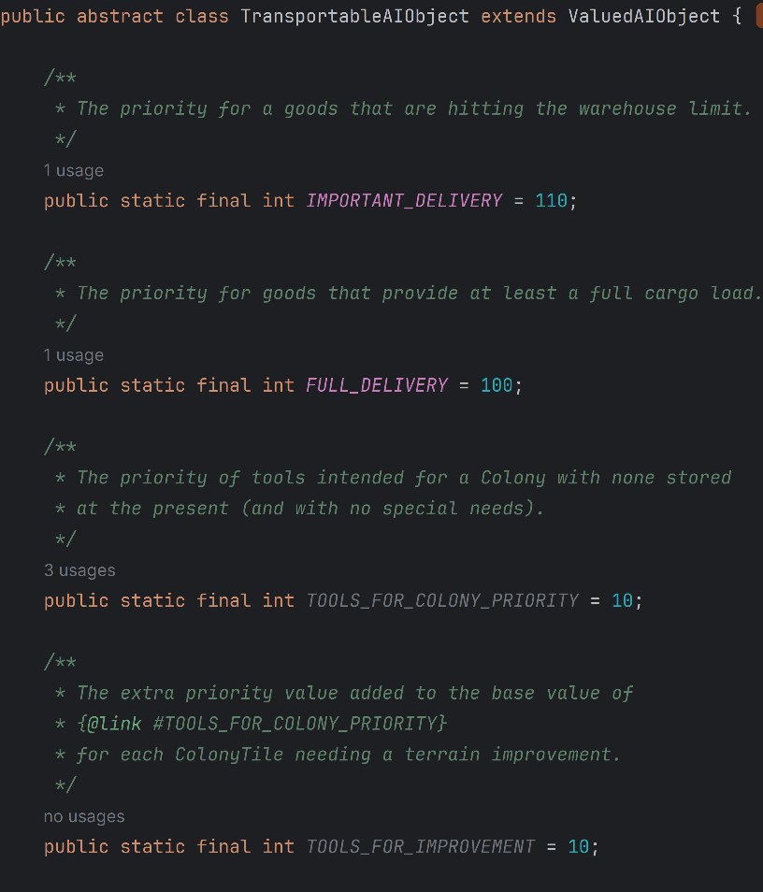

Some abstract methods - Abstract Class TransportableAIObject:

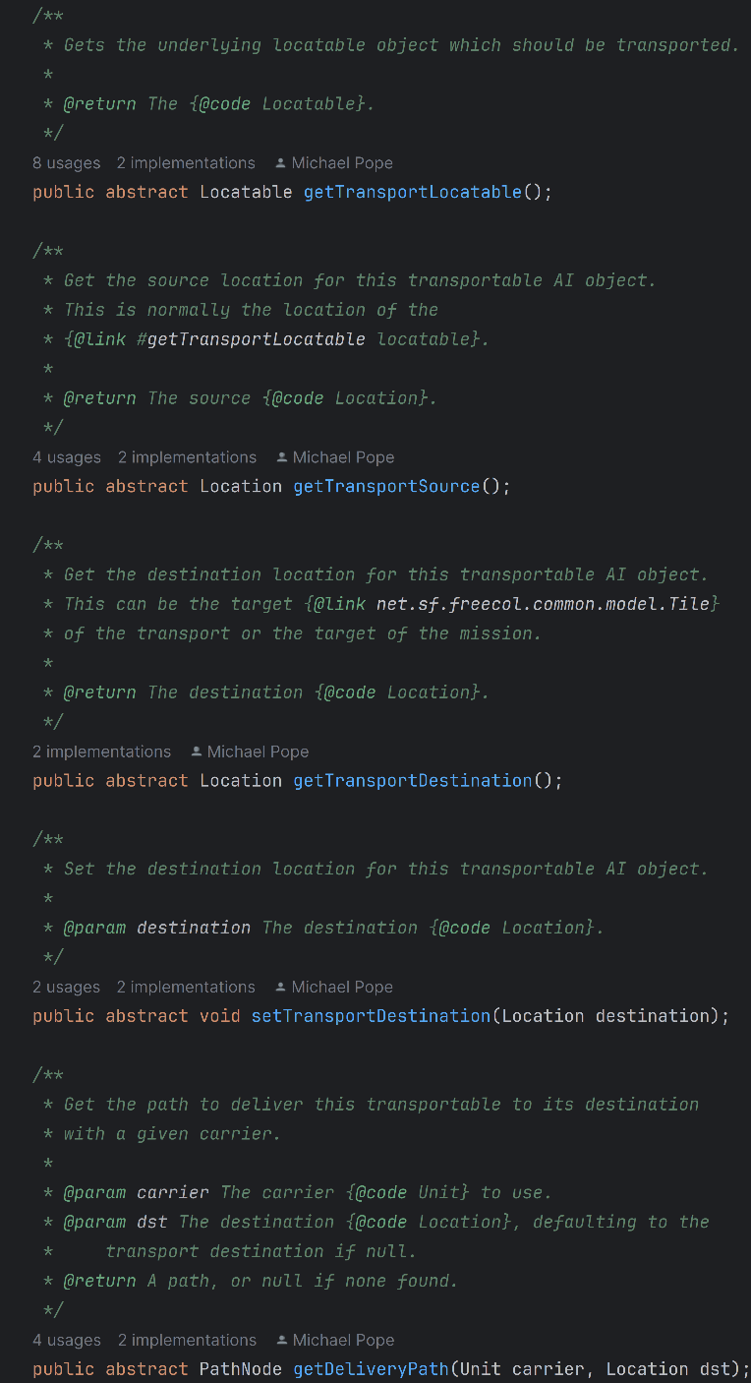

Implementation of abstract methods in the class AIUnit:

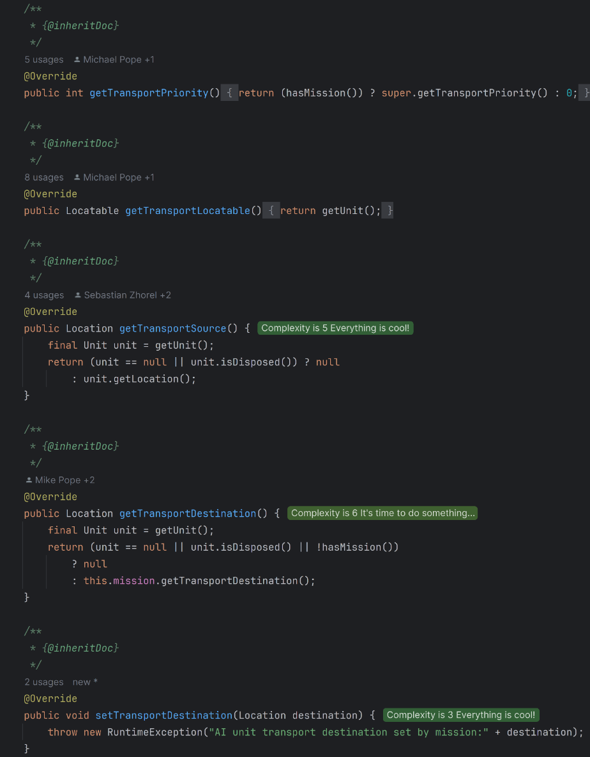

Implementation of abstract methods in the class AIGoods:

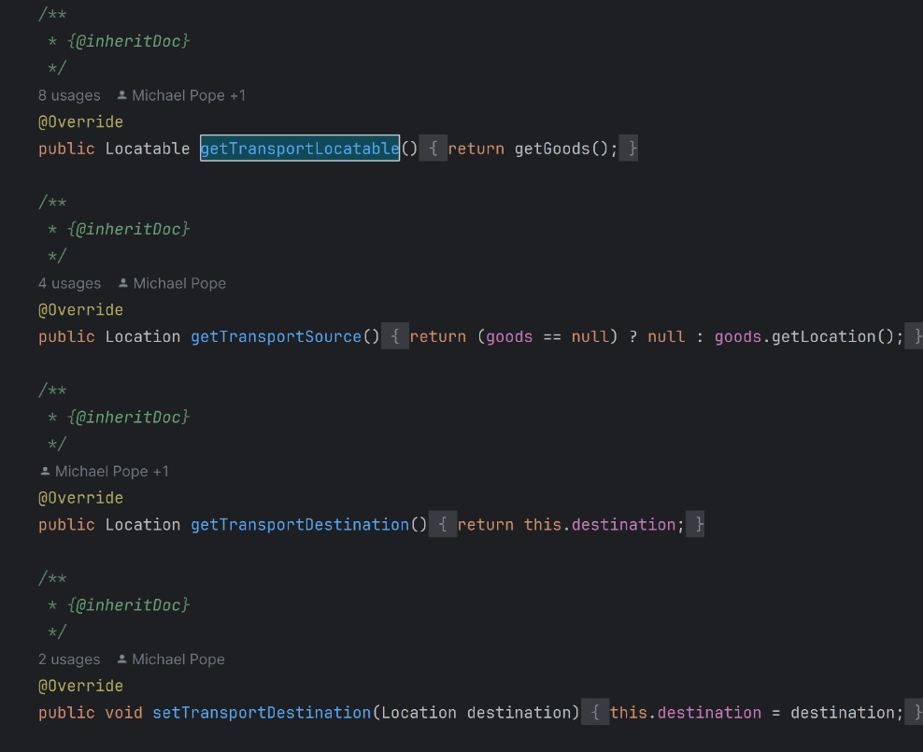

In addition to these methods, other methods such as **getDeliveryPath(Unit carrier, Location dst)/ getIntermediatePath(Unit carrier, Location dst)/ carriableBy(Unit carrier)/ canMove()/leaveTransport()/leaveTransport(Direction direction)/ joinTransport(Unit carrier, Direction direction)/ invalidReason()** are also implemented in the subclasses.

**Class diagram**:

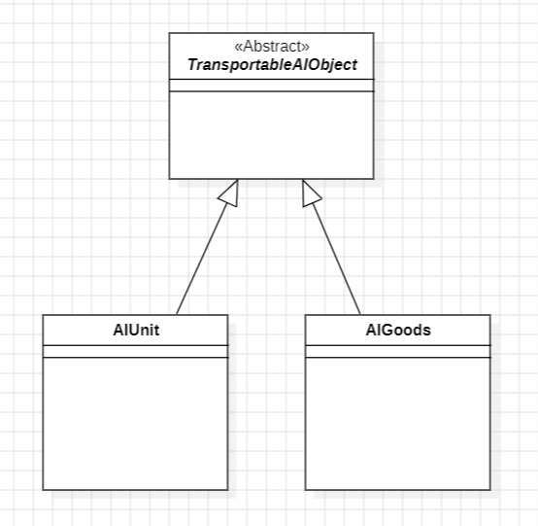

**By**: Renata Henriques (63001) -> Renata-Tournour (team_member6)

## Design Pattern 23

**Type**: Command

**Location:**

MapTransform:

Game.src.net.sf.freecol.client.control.MapTransform.java

RiverStyleTransform:

Game.src.net.sf.freecol.client.gui.panel.MapEditorTransformPanel.java

MapEditorController:

Game.src.net.sf.freecol.client.control.MapEditorController.java

Command is a design pattern that encapsulates a request as its own object, allowing a command to be treated as an object. In the FreeCol code, the Command class is represented by the MapTransform class, an abstract class that defines the common interface for transformation commands. The classes (RiverStyleTransform, RiverTransform, ResourceTransform, LostCityRumourTransform, SettlementTransform, TileTypeTransform) that extend MapTransform are considered concrete commands, and the MapEditorController class serves as the invoker by calling the transform(Tile t) method, which determines how the transformation is applied to the Tile t.

**Code snippet:**

MapTransform:

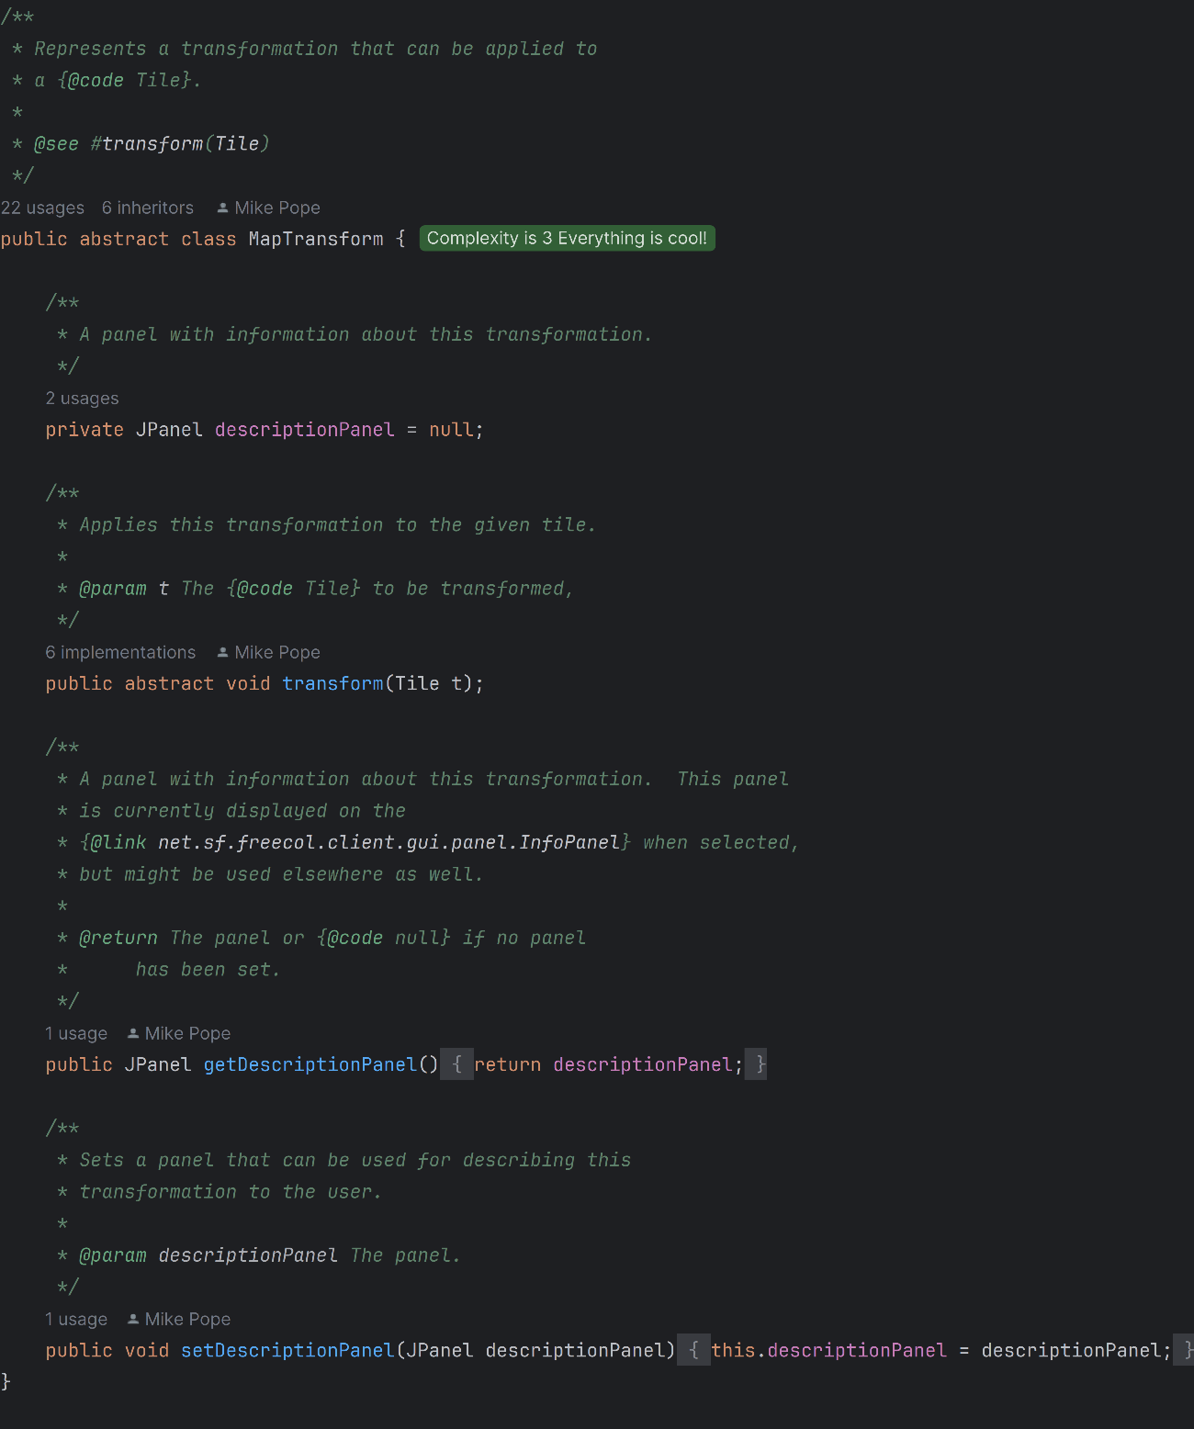

RiverStyleTransform:

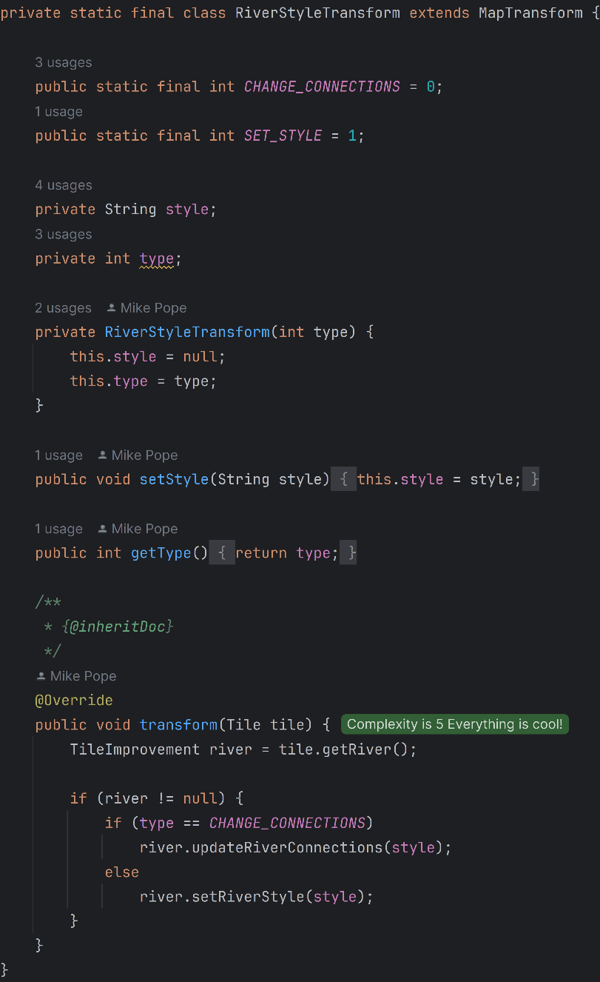

MapEditorController:

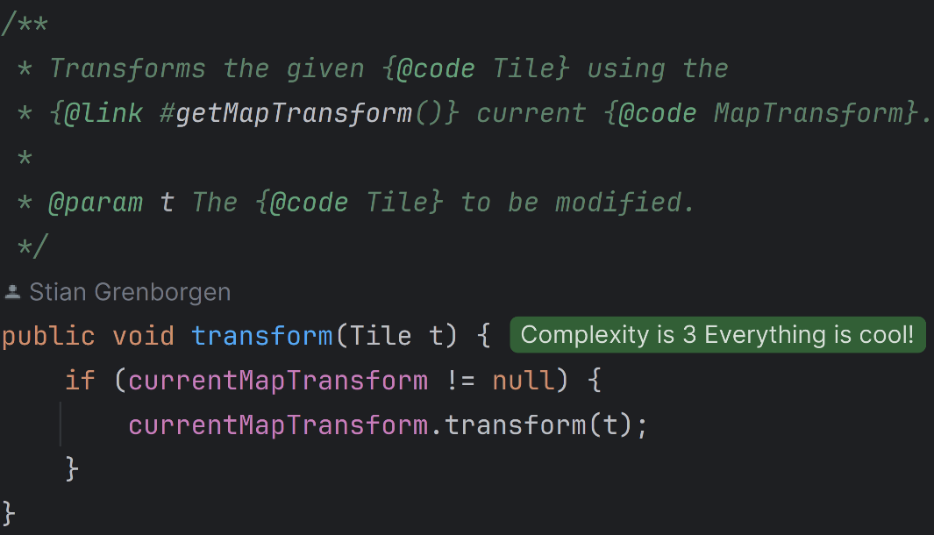

**Class Diagram:**

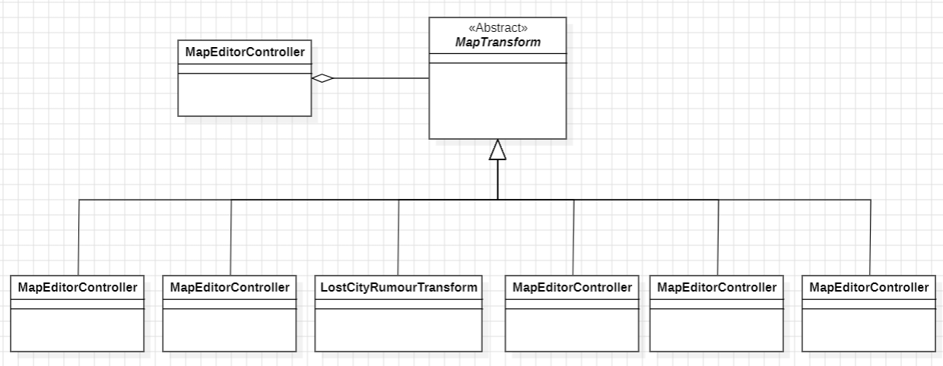

**By**: Renata Henriques (63001) -> Renata-Tournour (team_member6)

## Design Pattern 24

**Type**: Memento

**Location:**

GameController:

Game.src.net.sf.freecol.client.control.InGameController.java

Europe:

Game.src.net.sf.freecol.common.model.Europe.java

EuropeWas:

Game.src.net.sf.freecol.common.model.EuropeWas.java

Memento allows you to save and later access a previous state of an object. The original object is responsible for creating the state snapshot, which is the state I want to save and this state is saved in a new object (memento). In freeCol code, the EuropeWas class works as our memento, it is responsible for remembering the state of Europe. Europe class works as our Originator and GameController Game Controller accesses the object created by the EuropeWas class to perform actions in the game.

**Code snippet:**

EuropeWas:

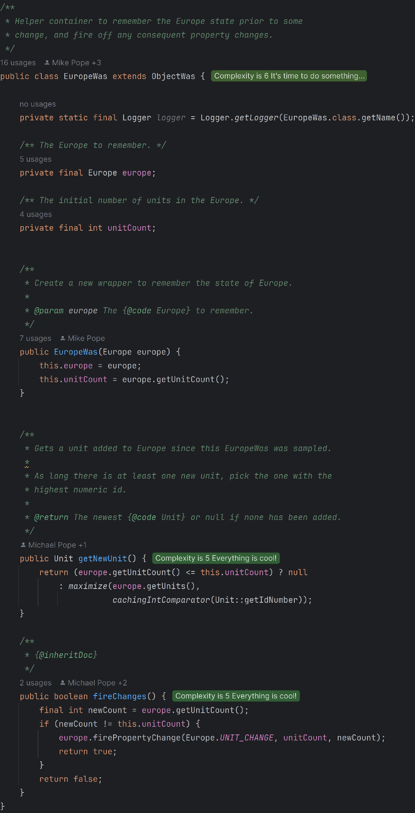

Part of Europe class:

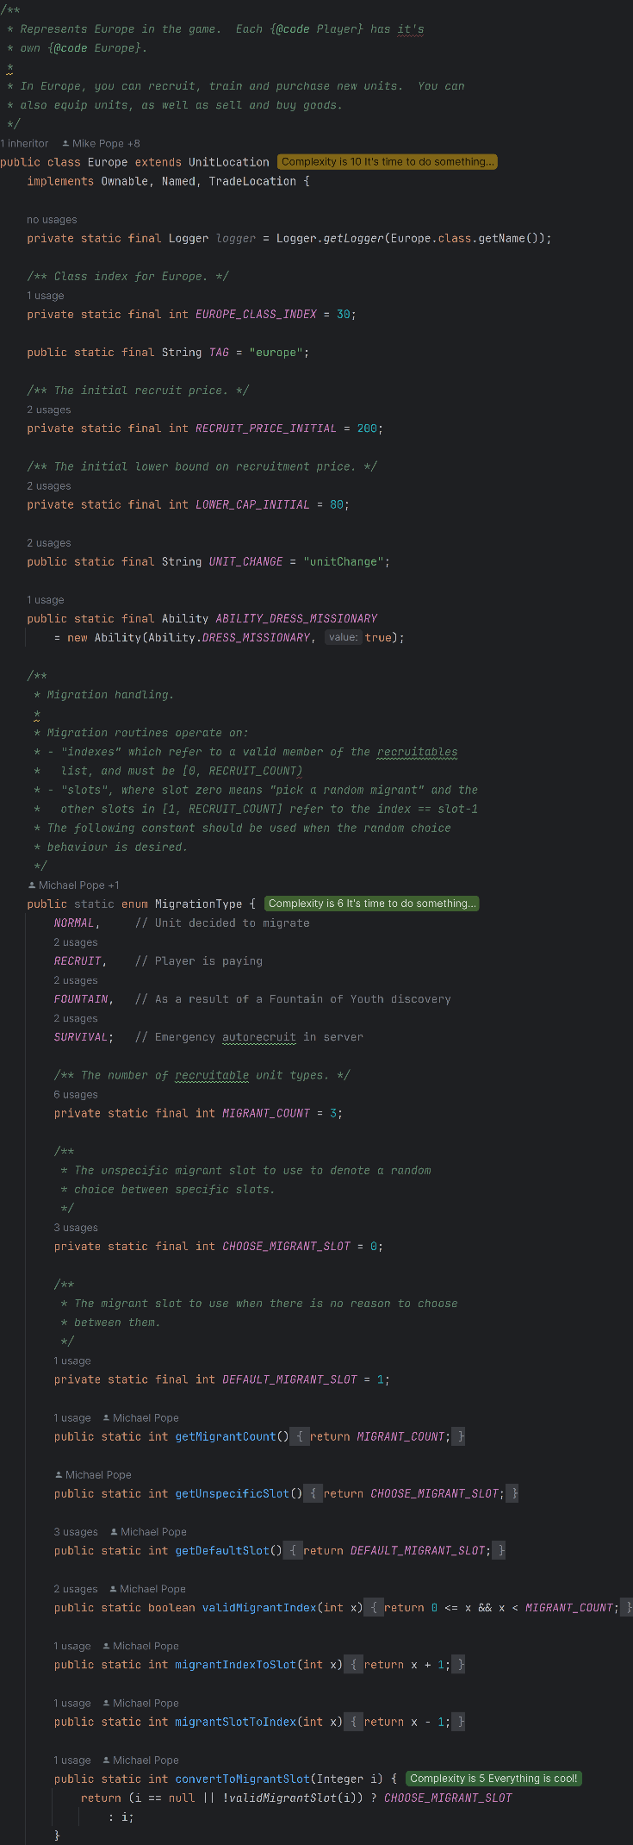

Examples of EuropaWas being used in GameController class:

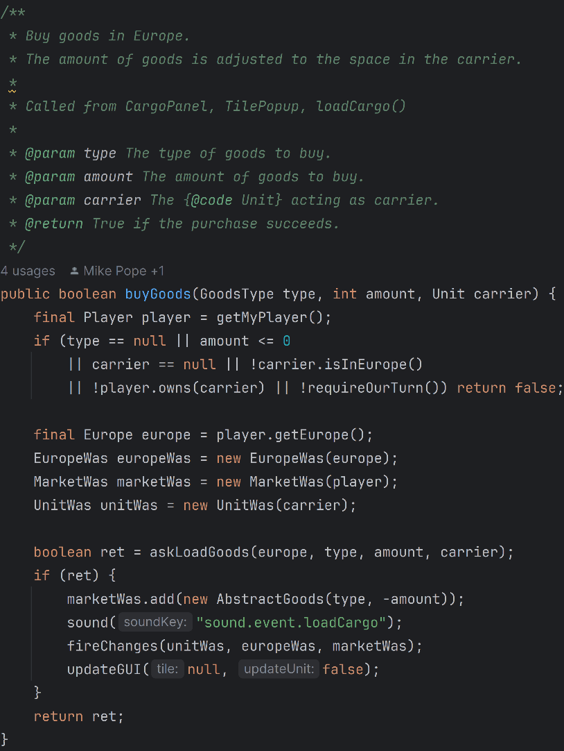

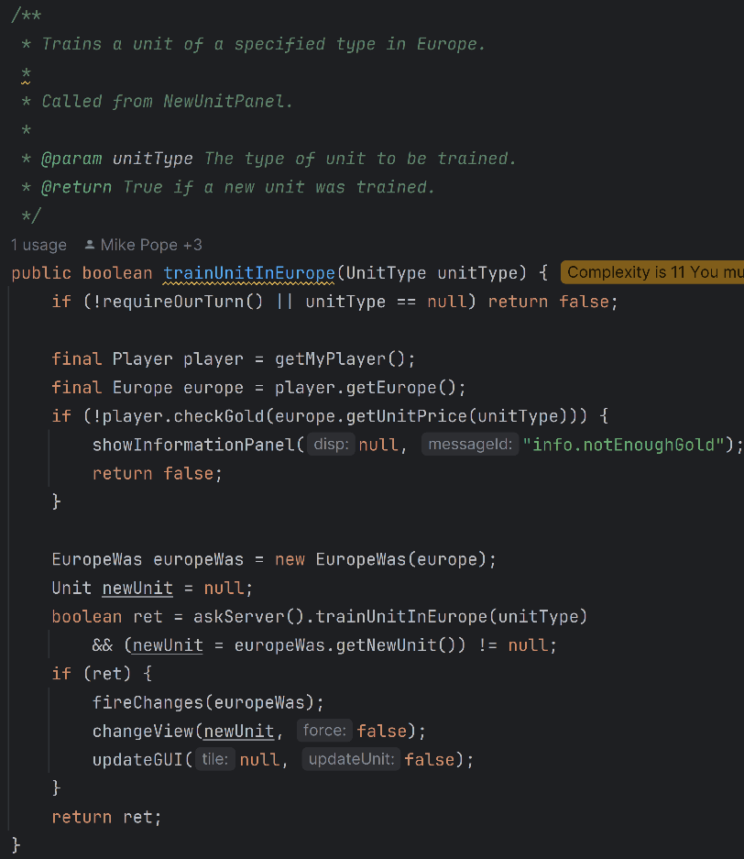

**Class Diagram:**

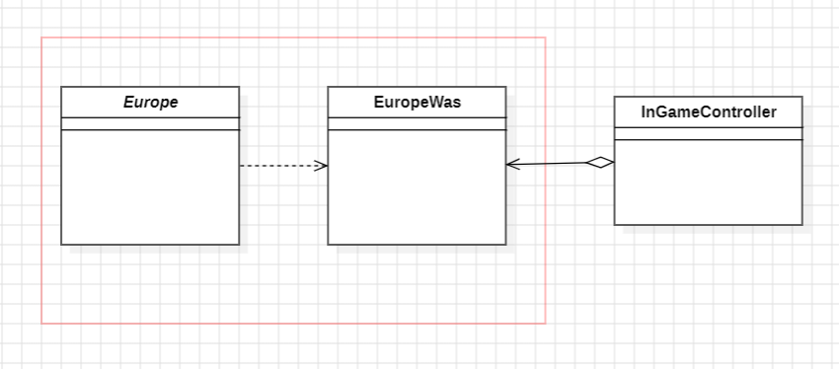

**By**: Renata Henriques (63001) -> Renata-Tournour (team_member6)

# Code Smells

## Code Smell 10

**Type**: Data class

**Location:** Game/src/net/sf/freecol/server/control/FreeColServerHolder.java

This class, in addition to being quite small, only has getter methods, having no specific functionality other than accessing the FreeColServer object. Therefore, due to its simplicity, I consider it to be a *Data Class* code smell. To try to remove this code smell, I suggest that, for example, some FreeColServer modification features could be implemented in this class since several classes access this object.

**Code snippet**:

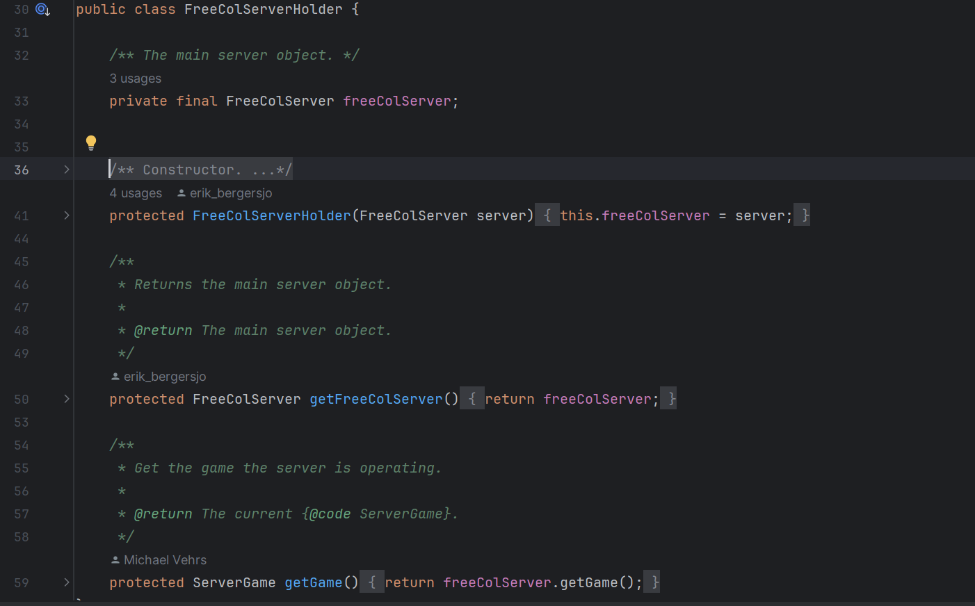

**By**: Beatriz Rosas (63179) -> beatrizSPR9 (team_member5)

## Code Smell 11

**Type**: Long method

**Location**: Game/src/net/sf/freecol/common/model/Player.java

This method has a total of 293 lines (from line 3665 to line 3958), making its analysis complicated and exhaustive. Therefore, I consider this to be the *Long Method* code smell. Due to this fact, I would recommend divide it into several auxiliar private methods, with each method being responsible for a specific part of the original method. This not only makes it easier to read but may even allow certain areas of the code not to be repeated.

**Code snippet**:

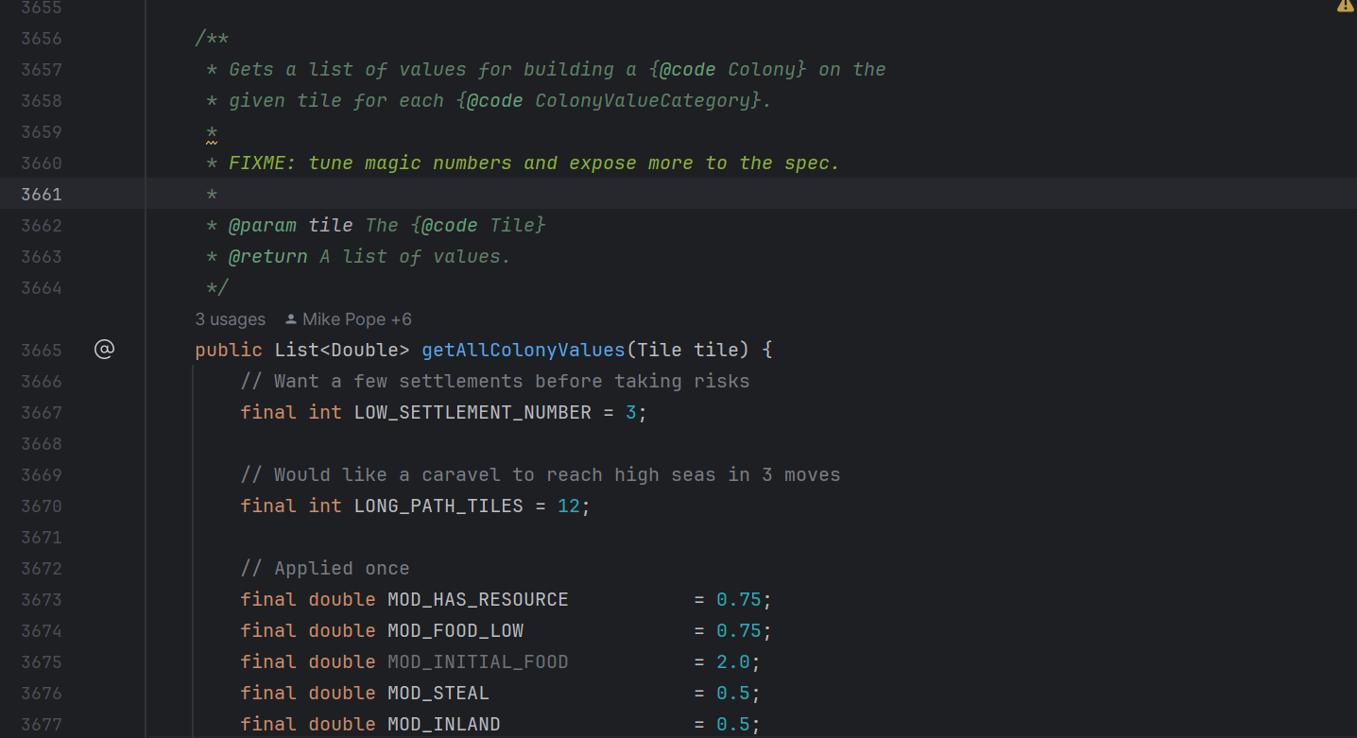

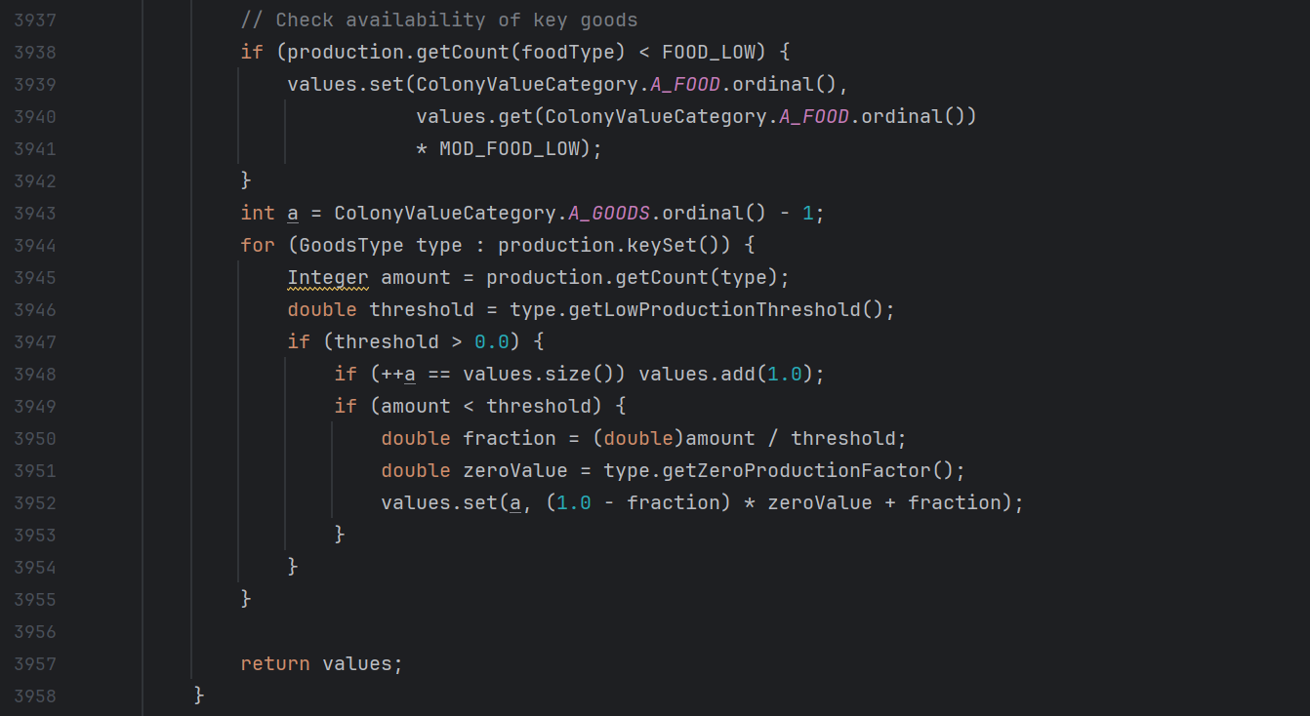

**By**: Beatriz Rosas (63179) -> beatrizSPR9 (team_member5)

## Code Smell 12

**Type**: Data clumps

**Location**: Game/src/net/sf/freecol/common/model/LandMap.java

In this class there are several methods that repeat the set of parameters “int x, int y”. This represents a *Data Clumps* code smell type. To remove this code smell, I would recommend creating a new Coordinate class that would be responsible for instantiating objects that had the variables x and y as attributes. Another solution would be to use the Position class found in Game/src/net/sf/freecol/common/model/Map.java since it has the variables x and y as attributes.

**Code snippet**:

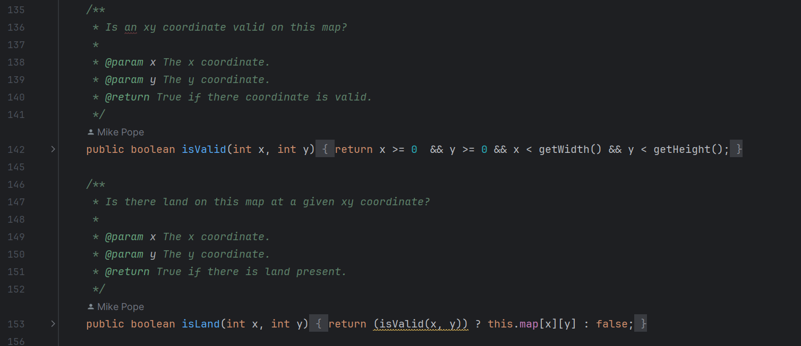



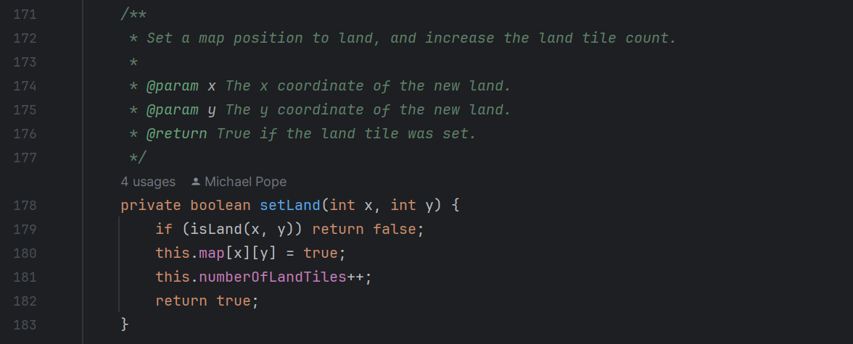

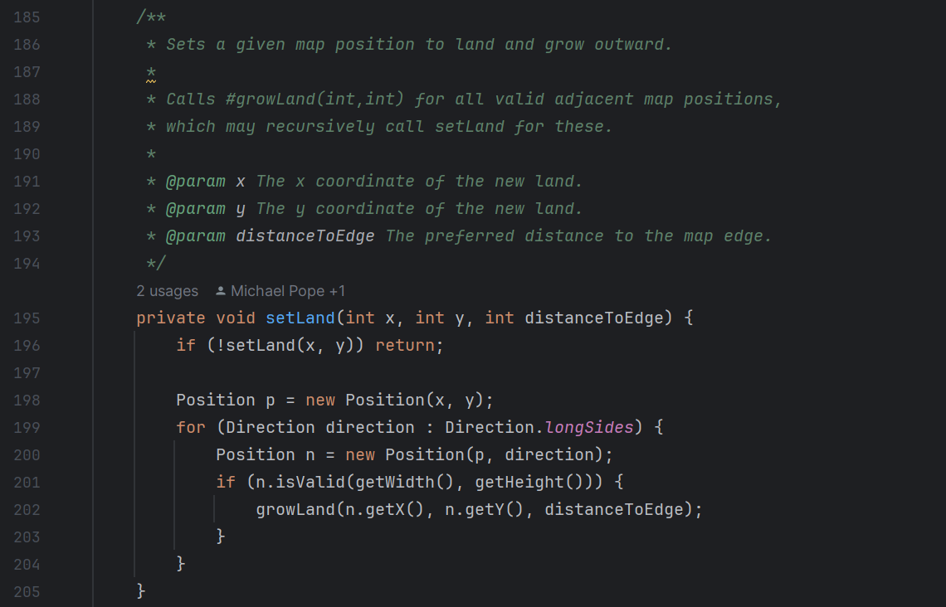

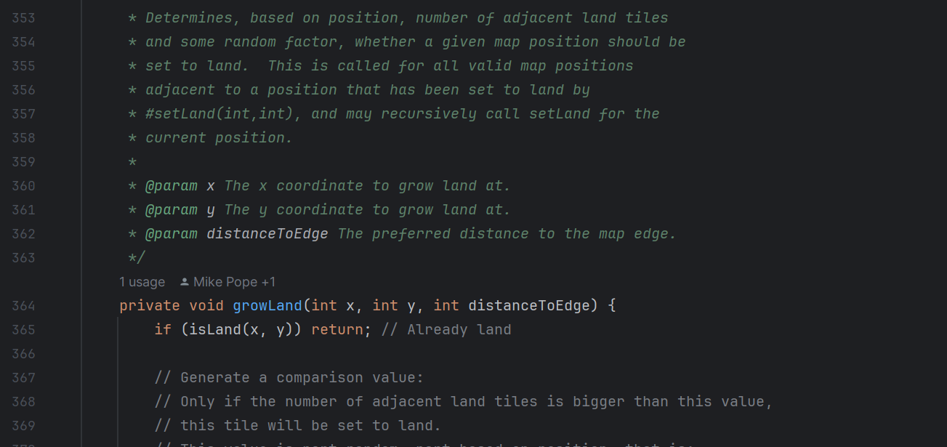



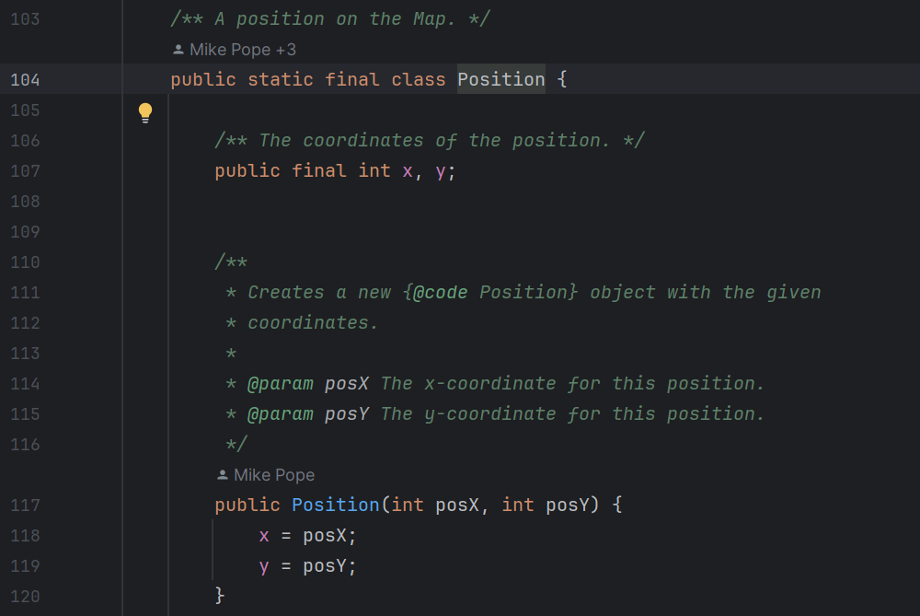

**By**: Beatriz Rosas (63179) -> beatrizSPR9 (team_member5)

## Code Smell 13

**-long parameter list**

Location: src>net.sf.freecol>client>gui>animation>animations.java

This code smell is characterized by a long number of parameters in a given method. Methods with this characteristic are difficult to use and increase the likelihood of potential errors. A solution to this code smell would be to pass an object as a parameter instead of so many variables.

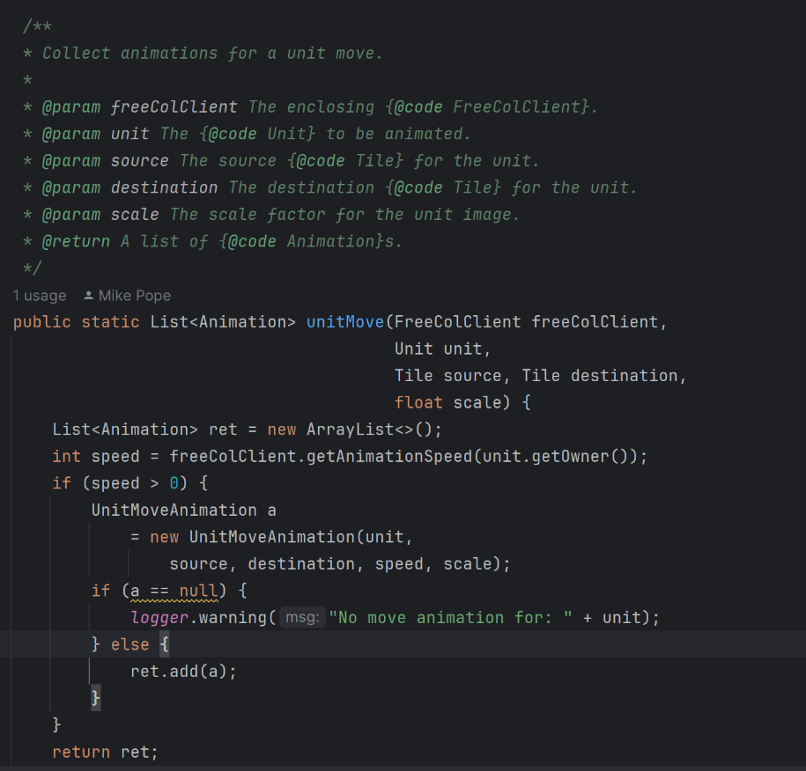

**By**: Joana Monteiro (62689) -> joanamonteiro1809 (team_member3)

## Code Smell 14

**-long method**

Location: src>net.sf.freecol>client>gui>dialog> selectDestinationDialog.java

This code smell is characterized by the existence of a long method. A long method means that the method is more complex than it should be. A solution to this code smell would be to take out a chunk of code that makes sense all together, create a separate method and call it inside the function.

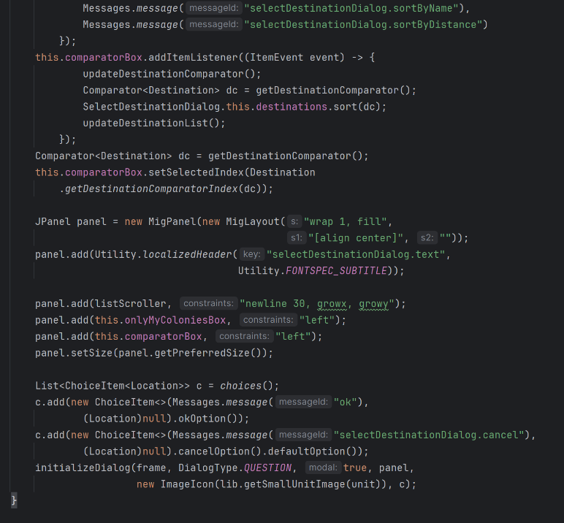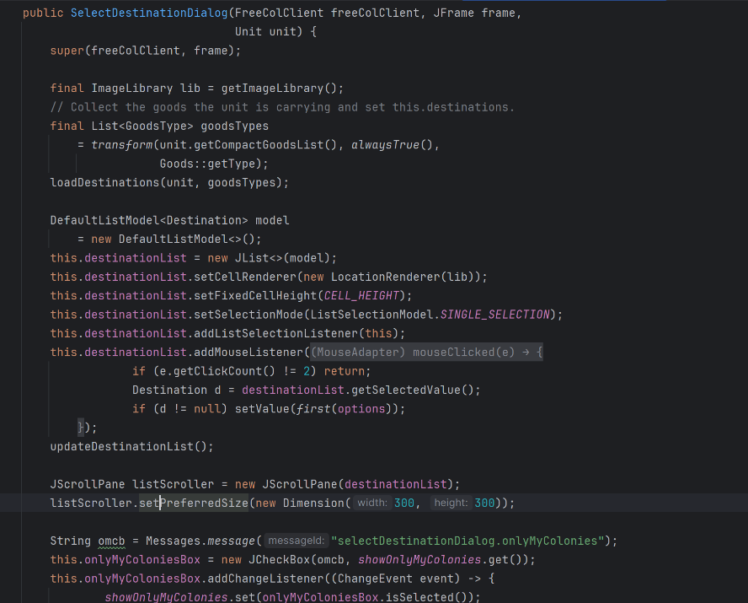

**By**: Joana Monteiro (62689) -> joanamonteiro1809 (team_member3)

## Code Smell 15

**-message chain**

Location: src>net.sf.freecol>server>model>ServerColony

This code smell is characterized by long message chains in which you call an object and get it back, then call another object and get it. This can cause rigidity in the code and make it more difficult to test independently. A possible solution would be to create different local variables in which each one calls the corresponding object, and pass these objects as parameters.

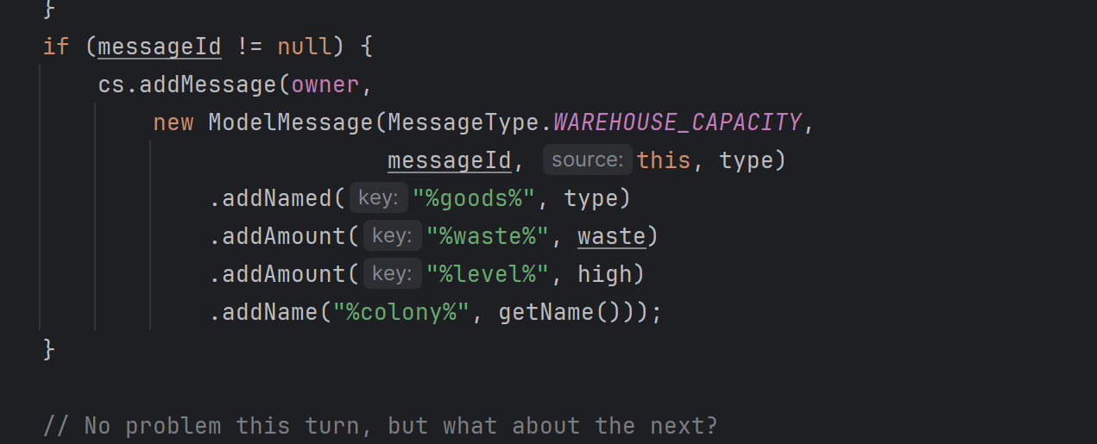

**By**: Joana Monteiro (62689) -> joanamonteiro1809 (team_member3)

Code Smell 16

**- Speculative Generality:**

Location: Game/scr/net.sf.freecol/common/model/Specifications.mergeGroup()

This method in the Specifications class is never used, even though it might be useful in the future it isn’t right now. Having that in mind the best solution to this code smell would be to remove the method.

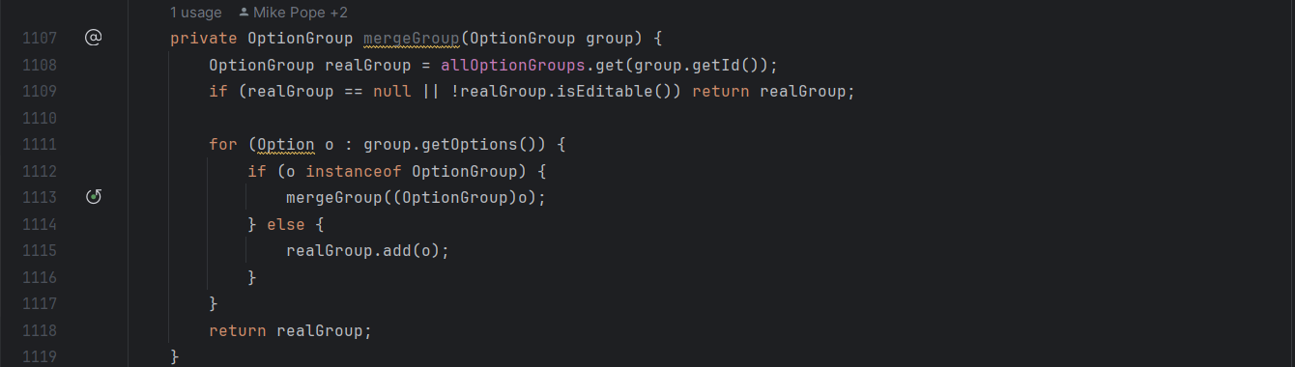

**By**: Catarina Costa (62497) -> cgcostaFCT (team_member2)

Code Smell 17

**- Data Class:**

Location: Game/src/ net.sf.freecol/common/model/Ability.java

This class contains only data, setter/getter methods, and no other functionality. A way to correct this would be to check if some functionalities would be better located in the Ability class and move them there.

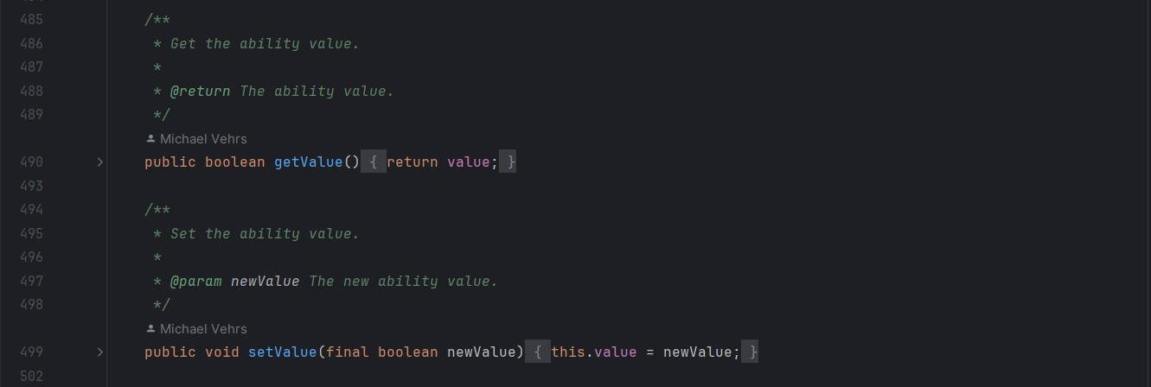

**By**: Catarina Costa (62497) -> cgcostaFCT (team_member2)

Code Smell 18

**- Long Method:**

Location: Game/src/ net.sf.freecol/common/model/Player.getAllColonyValues()

This method is one of the biggest in the whole project it has a total of 293 lines, which makes it hard to understand and might mean that it is more complex than it should be, because of this a possible solution would be to look for chunks of code that could be separated into its own method making the original simpler and more focused.

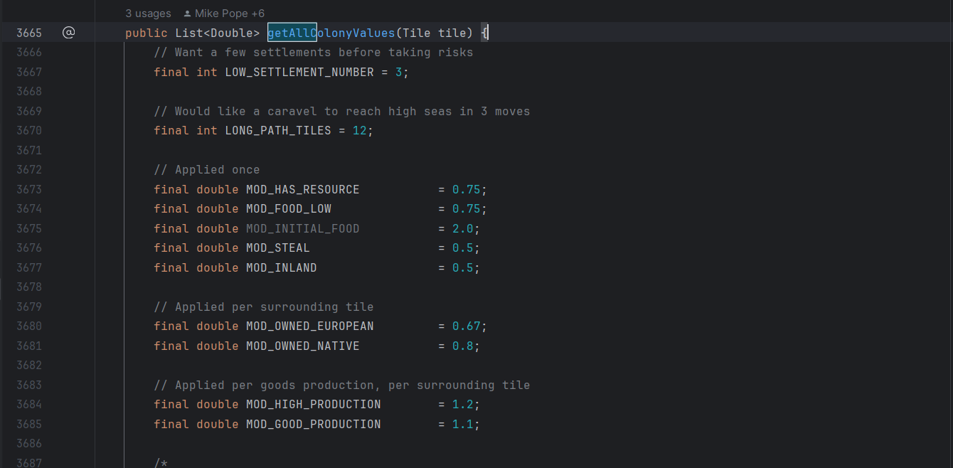

**By**: Catarina Costa (62497) -> cgcostaFCT (team_member2)

## Code Smell 19

**Type**: Long Method

**Location**: Game.src.net.sf.freecol.server.model.ServerPlayer.csCombat(…)

I found this method while analyzing my metric Lines of Code. This is the longest method in the whole program with 495 lines.

Solution: To remove the smell, I suggest the addition of smaller auxiliar methods, the main method can call, making it easier to understand what the method does.

**Code snippet:**

|  |  |
| --- | --- |
|  |  |

**By**: Madalena Plácido (63001) -> mplacido3 (team_member4)

## Code Smell 20

**Type**: Data Class

**Location**: Game.src.net.st.freecol.common.option.RangeOption

This class has nothing but getter and setter methods.

Solution: To remove the smell, I suggest adding other methods to give the class functionality.

**Code snippet**:

|  |
| --- |
|  |

**By**: Madalena Plácido (63001) -> mplacido3 (team_member4)

## Code Smell 21

**Type**: Long Parameter List

**Location**: Game.src.net.sf.freecol.common.model.Map.searchMap(…)

I found this method while analyzing my metric Lines of Code. This is the fourth longest method in the program, but what brought my attention was its 8 parameters.

Solution: To remove the smell, I suggest the introduction of parameter objects or the creation of global variables.

**Code snippet**:

|  |
| --- |
|  |

**By**: Madalena Plácido (63001) -> mplacido3 (team_member4)

## Code Smell 22

**Type**: Message Chains

**Location**:

Game.src.net.sf.freecol.client.control.InGameController.java - moveDirection(Unit unit, Direction direction, boolean interactive)

It's possible to observe the presence of a Message Chain when a client requests an object, and this object requests another, and so on. This means that the client is dependent on navigation along the class structure.

**Code snippet**:

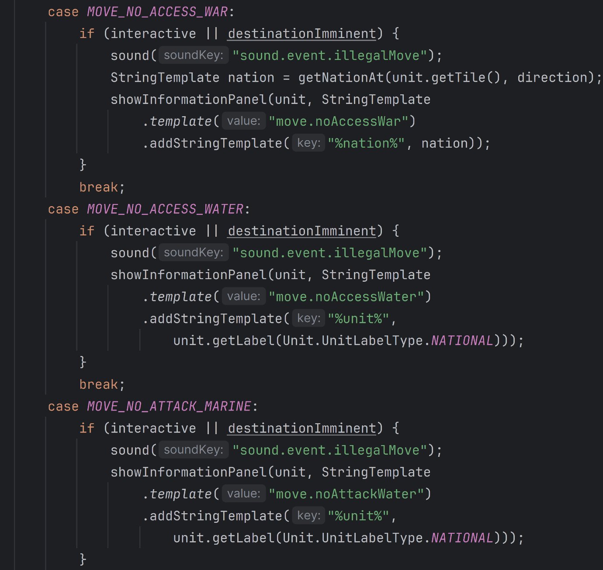

**Solution:**

To remove the smell, I suggest hiding all of the calls under a single method, so that they can become private.

**By**: Renata Henriques (63001) -> Renata-Tournour (team_member6)

## Code Smell 23

**Type**: Long method

**Location**:

Game.src.net.sf\freecol\common\model\Map.java > searchMap(final Unit unit, final Tile start, final GoalDecider goalDecider, final CostDecider costDecider, final int maxTurns, final Unit carrier, final SearchHeuristic searchHeuristic, final LogBuilder lb)

This method is one of the biggest of the project, it has 308 lines, which makes it hard to understand and might mean that it is more complex than it should be and dependent. By reducing its size, it becomes more functional, easier to understand and easier to restructure if necessary.

**Code snippet**:

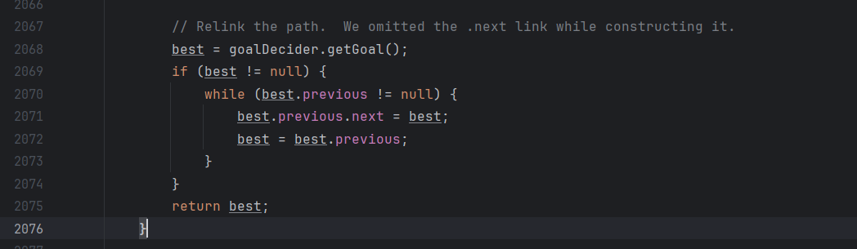

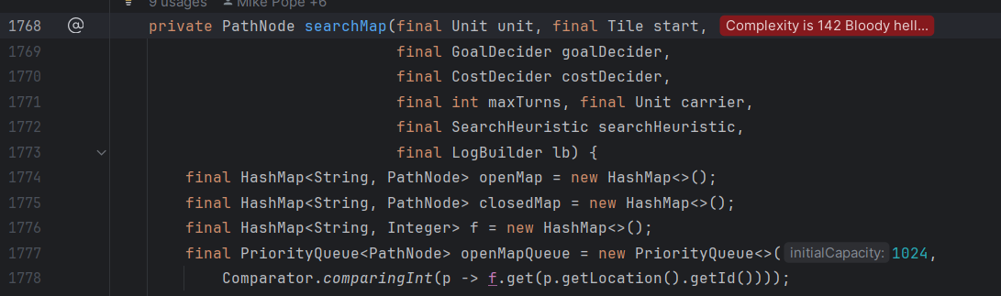

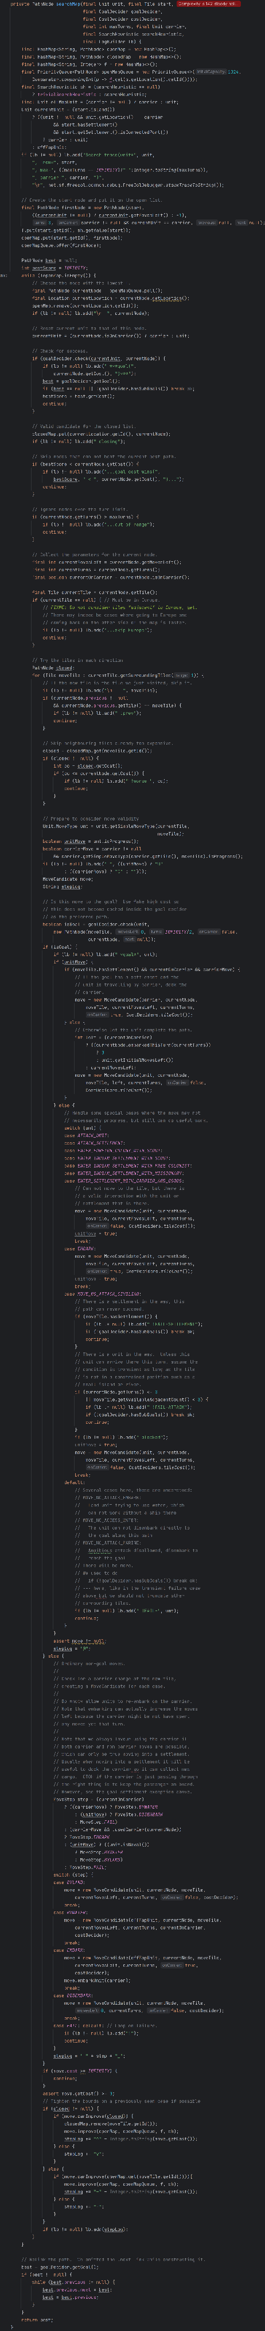 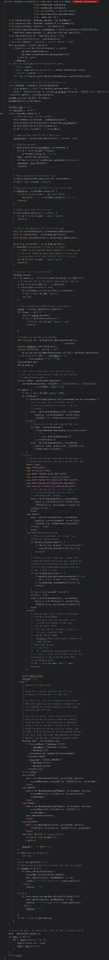

**Solution:**

To remove the smell, I suggest the addition of smaller auxiliar methods. One way to reduce its size would be to create auxiliary methods for the loops.

**By**: Renata Henriques (63001) -> Renata-Tournour (team_member6)

## Code Smell 24

**Type:** Long parameter list

**Location**:

Game.src.net.sf.freecol.client.gui.dialog.FreeColStringInputDialog.java > FreeColStringInputDialog(FreeColClient freeColClient, JFrame frame, boolean modal, StringTemplate tmpl, String defaultValue, String okKey, String cancelKey)

A long list of parameters might happen after several types of algorithms are merged in a single method. The found method has 7 parameters.

**Code snippet**:

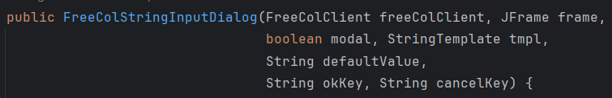

**Solution:**

To remove the smell, I suggest that instead of using a long list of parameters, a method can use the data from its own object.

**By**: Renata Henriques (63001) -> Renata-Tournour (team_member6)